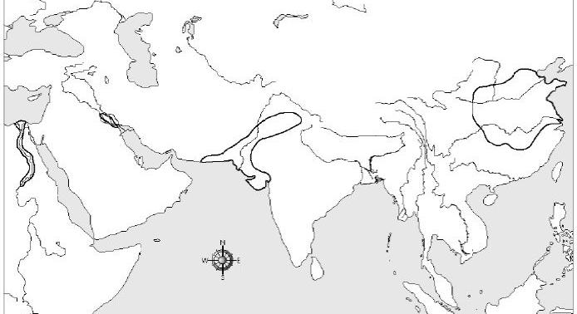
Egypt: Nile Mesopotamia:
Euphrates and Tigris

Indus Valley China
Indus River Huange He
D
C
B
A
- Be able to identify the following civilizations, major rivers and interesting facts about each location.

- Know your vocabulary words
- Reservoir: Used to store water
- Levies: A wall used to block flooding made of earth and mud
- Canals: an artificial waterway constructed to allow the passage water for irrigation.
- Dams: a barrier constructed to hold back water in a river
- Irrigation: the supply of water to land or crops to help growth, typically by means of channels
- Silt: Nutrient rich soil found on the bottom of a river that is deposited on land during a flood
- Aqueduct: Invented by the Romans it is an artificial channel for conveying water, typically in the form of a bridge across a valley or other gap.
- City-State: A city that with its surrounding territory forms an independent state. It has its own ruler and laws.

- What does Mesopotamia mean?
Land between the rivers

- Compare and Contrast Egyptian Civilization with Ancient Chinese Civilization
Both Egypt and China relied on the flooding of the rivers to provide fresh water and fertile soil for farming. Egypt considered the Nile a gift where China called the Huange He river the “River of Sorrows”

- Explain the significance of the geography of Greece

The mountains, hills, islands, and because it was on a peninsula made it very difficult to travel, to farm, to share ideas or to be united. Therefore the people had to rely on the sea for food and for travel. Greece also developed city-states instead of one government body.

- What advantage do mountains, hills and deserts offer civilizations?

A natural Barrier to defense

- What disadvantage do mountains, hills and deserts offer civilizations?
Isolation that makes trade and the spread of new information/ideas difficult

- What are physical characteristics?

Land features such as rivers, mountains and deserts. It also includes the animal and plant life in an area.

- Know the advantages and disadvantages of the different physical features
 | Positive | Negative
River | Fresh water, transportation, fish, silt | flooding
Monsoon | Fresh water, cool off country | Flooding, dry air in winter
Mountain | Barrier to defense | Isolation, poor farmland
Peninsula | Connection to the ocean for trade | Isolated from main land
Desert | Barrier to defense | Isolation, poor farmland

- Know about the Bering Land Bridge and its significance

This is a theorized land or ice bridge that connected Asia to Alaska. It allowed for the first Americans to migrate over to the new world. This was a very slow process that occurred over thousands of years and began about 15,000 years ago.

- Why did early civilizations settle near bodies of water?
Needed for survival. Needed to water their farmland and needed for their animals and humans to drink.

- List the significant facts about irrigation, reservoirs, canals and dikes

All are used as a way to control flood waters

- Explain the significance in agriculture and how it relates to the first settlements
The witch from nomadic hunter gatherers to farmers could not have happened until the invention of farming. This is called agriculture. Domestication of plants and animals is what led to the first civilization in Mesopotamia.

