Optional Take Home Test Fraction Name: _____________________________Core: ____

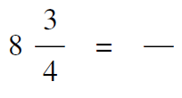
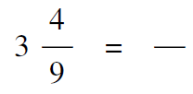
- Give an equivalent, improper fraction for each mixed number
1) 2)

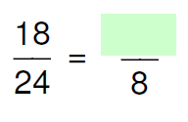
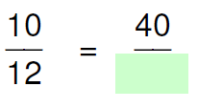
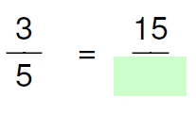
- Find the missing number in the equivalent fraction
3) 4) 5)

6. $1\frac{7}{15}+2\frac{7}{10}$ 7. $3\frac{1}{3}-2\frac{5}{8}$ 8. $3\frac{3}{4}∙6$ 9. $1\frac{3}{5}÷2\frac{1}{2}$

10. A bag contains 21 cups of dog food. Your two dogs each eat $2\frac{1}{8}$ cups of dog food each day. How many days will the bag of dog food last? (Hint: Answer must work for a real world situation.)

11. You make skateboard ramps by cutting pieces from a board that is $12 \frac{1}{2}$ feet long. Each ramp is $1 \frac{3}{4}$ feet long. How many ramps can you cut from the board? (Hint: Answer must work for a real world situation.)

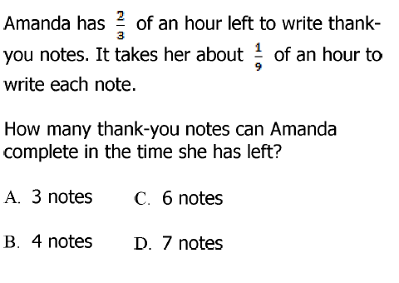
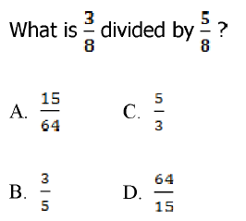
____12. ____ 13.

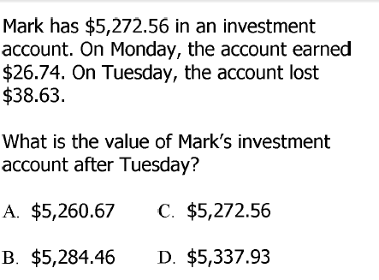
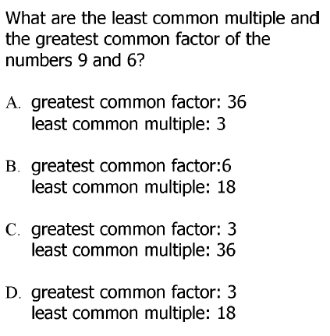
____ 14. ____ 15.

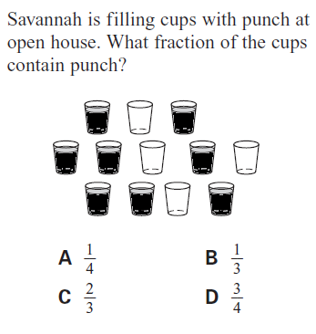
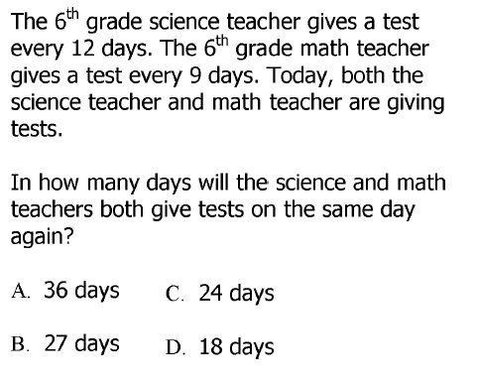
____ 16. ____ 17.

____ 1)

- Compare fractions using < , > , =
18) 19)

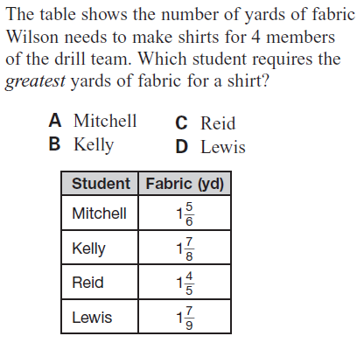
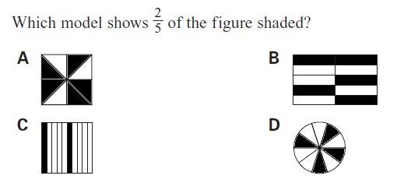
____ 20. ____ 21.

____ 22.)
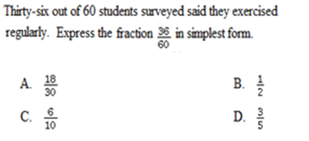

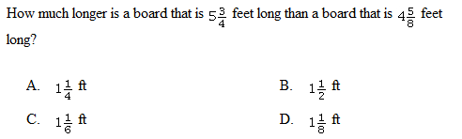
____ 23.

