Common Core Lesson Plan

Topic: Ancient India/Ancient Egypt Title: Indian Monsoon Cycle and Egyptian Flooding

Overview: Through this multi-day lesson students will analyze the similarities and differences between the monsoon cycle in India and the annual flooding of the Nile River in Egypt. Students will, during the course of the 6th grade curriculum, have an understanding of the impact of a civilization’s environment on the development of that culture both in terms of culture and economics.

Resources (primary resource documents, artifacts, material needs, etc.)

Common Core Standards
RH.6-8.1, 2, 4, 7

Essential Standards
6.H.1.2
6.H.1.3
6.G.1.1
6.G.1.2
6.G.1.3
6.G.1.4
6.G.2.1
6.G.2.2
6.C.1.1

Background Information

Instructional Sequence (before, during, and after instruction)
Step 1
Students will read, annotate, and answer comprehension questions about the Indian monsoon and Egyptian flooding (There are three levels of this text)

Step 2
Students will, with the support of their teacher’s model, create maps indicating the progression of the monsoon/flood cycle

Step 3
Students will read, interact with vocabulary, and answer comprehension questions about the primary sources “Hymn to the Nile” and “Indra and the Monsoons”. (There are three levels of this text)

Step 4
Students will use the vocabulary from step 3 to create visual and literary representations of selected words.

Step 5
Students will use the attached chart to summarize their findings and understandings regarding the similarities and differences between the Indian Monsoon cycle and annual flooding of the Nile in Ancient Egypt
Indian Weather and the Monsoon Cycle
In late spring, the grassy plains and forested hillsides of southwestern India are among the hottest places on earth, with temperatures regularly edging above 100 degrees. In the stifling heat, "nature seems to be frozen in time," writes Indian short story author Shantipriva. "The air is on fire and the leaves are perfectly still as if holding their breath." Still, he writes, "there is a curious sense of anticipation.”
How does the author describe India in late spring?
That is because Indians know that as the baking-hot air around them rises high into the sky, it slowly sucks in a blanket of cool, moist air from the nearby ocean. As the two great air masses collide each June, the once still leaves begin to flutter in the arriving sea winds. The sky darkens as the sun disappears beneath a blanket of scudding clouds. Then, seemingly in an instant, sheets of rain are gushing across the parched landscape. The heavy, spattering raindrops announce the arrival of the life-giving monsoon. "With its life-giving rain and its wild storms, the monsoon is a mixed blessing: whimsical, unpredictable and unmistakably Indian," says Shantipriya. It is also a breathtaking spectacle that annually shapes the lives of both the people of India and the country's wildlife. The Indian Monsoon, which climate scientists call one of the most intense annual weather events in the world, begins in early June and lasts for several months. Many Indians fear the monsoon's deadly floods, which regularly sweep away unlucky communities. But farmers also rely on it to coax their crops from the soil. Indeed, without the monsoon's storms, which can deliver up to 90 percent of a year's rainfall, almost a billion people would starve.
Describe the Indian Monsoon:
Parched: Extremely dry
Annual Flooding of the Nile in Egypt
The Nile's waters increase in the summer due to the heavy rainfall that occurs in the tropical Ethiopian highlands. In April, flooding begins in southern Sudan. It is July before the floods reach Aswan, Egypt. The river continues to rise until it peaks in mid-September. In Cairo, the floods are delayed until October. After the river has peaked, the levels fall quickly during November and December. The Nile is at its lowest levels between March and May. The annually recurring flooding can now be controlled by means of the Aswan Dam.
Recurring: Returning

Were it not for the Nile River, Egyptian civilization could not have developed, as it is the only significant source of water in this desert region. Its other importance was the fact that it was their gateway to the unknown world. The Nile flows from south to north, to its delta on the Mediterranean Sea. It would flood each year, bringing in silt-laden waters; when the waters receded the silt would stay behind, fertilizing the land, the silt would be helpful for growing crops. If a flood were too large it would wash over mud dykes protecting a village. A small flood or no flood at all would mean famine. A flood must be of just the right intensity for a good season.
Describe the flooding of the Nile:

- What sort of preparations might a modern Egyptian or Indian need to make before the flood or monsoon each year?

- What sort of preparations would an inhabitant of Ancient India or Ancient Egypt need to make before the coming flood/monsoon?

- What are two advantages and two disadvantages to the monsoon cycle in India?

- What are two advantages and two disadvantages of the annual flooding of the Nile in India?

Indian Weather and the Monsoon Cycle
In late spring, the grassy plains and forested hillsides of southwestern India are among the hottest places on earth, with temperatures regularly edging above 100 degrees. In the stifling heat, "nature seems to be frozen in time," writes Indian short story author Shantipriva. "The air is on fire and the leaves are perfectly still as if holding their breath." Still, he writes, "there is a curious sense of anticipation.”
How does the author describe India in late spring?
That is because Indians know that as the baking-hot air around them rises high into the sky, it slowly sucks in a blanket of cool, moist air from the nearby ocean. As the two great air masses collide each June, the once still leaves begin to flutter in the arriving sea winds. The sky darkens as the sun disappears beneath a blanket of scudding clouds. Then, seemingly in an instant, sheets of rain are gushing across the parched landscape. The heavy, spattering raindrops announce the arrival of the life-giving monsoon. "With its life-giving rain and its wild storms, the monsoon is a mixed blessing: whimsical, unpredictable and unmistakably Indian," says Shantipriya. It is also a breathtaking spectacle that annually shapes the lives of both the people of India and the country's wildlife. The Indian Monsoon, which climate scientists call one of the most intense annual weather events in the world, begins in early June and lasts for several months. Many Indians fear the monsoon's deadly floods, which regularly sweep away unlucky communities. But farmers also rely on it to coax their crops from the soil. Indeed, without the monsoon's storms, which can deliver up to 90 percent of a year's rainfall, almost a billion people would starve.
Describe the Indian Monsoon:
Annual Flooding of the Nile in Egypt
The Nile's waters increase in the summer due to the heavy rainfall that occurs in the tropical Ethiopian highlands. In April, flooding begins in southern Sudan. It is July before the floods reach Aswan, Egypt. The river continues to rise until it peaks in mid-September. In Cairo, the floods are delayed until October. After the river has peaked, the levels fall quickly during November and December. The Nile is at its lowest levels between March and May. The annually recurring flooding can now be controlled by means of the Aswan Dam.
Were it not for the Nile River, Egyptian civilization could not have developed, as it is the only significant source of water in this desert region. Its other importance was the fact that it was their gateway to the unknown world. The Nile flows from south to north, to its delta on the Mediterranean Sea. It would flood each year, bringing in silt-laden waters; when the waters receded the silt would stay behind, fertilizing the land, the silt would be helpful for growing crops. If a flood were too large it would wash over mud dykes protecting a village. A small flood or no flood at all would mean famine. A flood must be of just the right intensity for a good season.

- What sort of preparations might an Egyptian or Indian need to make before the flood or monsoon each year?

- What sort of preparations would an inhabitant of Ancient India or Ancient Egypt need to make before the coming flood/monsoon?

- What are two advantages and two disadvantages to the monsoon cycle in India?

- What are two advantages and two disadvantages of the annual flooding of the Nile in India?

Indian Weather and the Monsoon Cycle
In late spring, the grassy plains and forested hillsides of southwestern India are among the hottest places on earth, with temperatures regularly edging above 100 degrees. In the stifling heat, "nature seems to be frozen in time," writes Indian short story author Shantipriva. "The air is on fire and the leaves are perfectly still as if holding their breath." Still, he writes, "there is a curious sense of anticipation.”
That is because Indians know that as the baking-hot air around them rises high into the sky, it slowly sucks in a blanket of cool, moist air from the nearby ocean. As the two great air masses collide each June, the once still leaves begin to flutter in the arriving sea winds. The sky darkens as the sun disappears beneath a blanket of scudding clouds. Then, seemingly in an instant, sheets of rain are gushing across the parched landscape. The heavy, spattering raindrops announce the arrival of the life-giving monsoon. "With its life-giving rain and its wild storms, the monsoon is a mixed blessing: whimsical, unpredictable and unmistakably Indian," says Shantipriya. It is also a breathtaking spectacle that annually shapes the lives of both the people of India and the country's wildlife. The Indian Monsoon, which climate scientists call one of the most intense annual weather events in the world, begins in early June and lasts for several months. Many Indians fear the monsoon's deadly floods, which regularly sweep away unlucky communities. But farmers also rely on it to coax their crops from the soil. Indeed, without the monsoon's storms, which can deliver up to 90 percent of a year's rainfall, almost a billion people would starve.
Annual Flooding of the Nile in Egypt
The Nile's waters increase in the summer due to the heavy rainfall that occurs in the tropical Ethiopian highlands. In April, flooding begins in southern Sudan. It is July before the floods reach Aswan, Egypt. The river continues to rise until it peaks in mid-September. In Cairo, the floods are delayed until October. After the river has peaked, the levels fall quickly during November and December. The Nile is at its lowest levels between March and May. The annually recurring flooding can now be controlled by means of the Aswan Dam.
Were it not for the Nile River, Egyptian civilization could not have developed, as it is the only significant source of water in this desert region. Its other importance was the fact that it was their gateway to the unknown world. The Nile flows from south to north, to its delta on the Mediterranean Sea. It would flood each year, bringing in silt-laden waters; when the waters receded the silt would stay behind, fertilizing the land, the silt would be helpful for growing crops. If a flood were too large it would wash over mud dykes protecting a village. A small flood or no flood at all would mean famine. A flood must be of just the right intensity for a good season.

- What sort of preparations might an Egyptian or Indian need to make before the flood or monsoon each year?

- What sort of preparations would an inhabitant of Ancient India or Ancient Egypt need to make before the coming flood/monsoon?

- What are two advantages and two disadvantages to the monsoon cycle in India?

- What are two advantages and two disadvantages of the annual flooding of the Nile in India?

For teacher use in the attached map activities

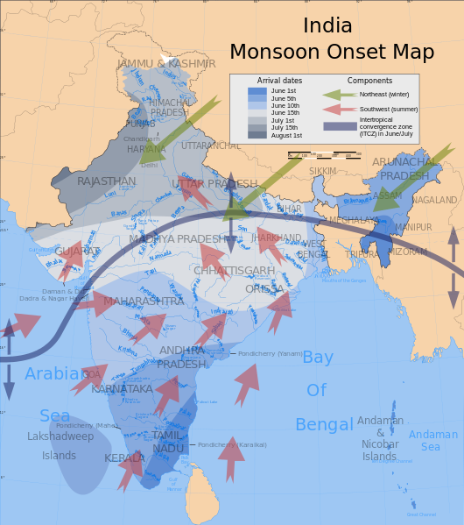

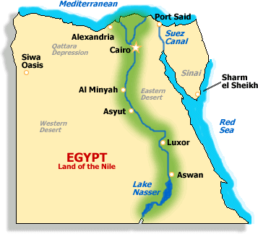

Name:_______________ India Monsoon Map

Directions: Using the sample provided, color the map to show the onset of the monsoon in India.
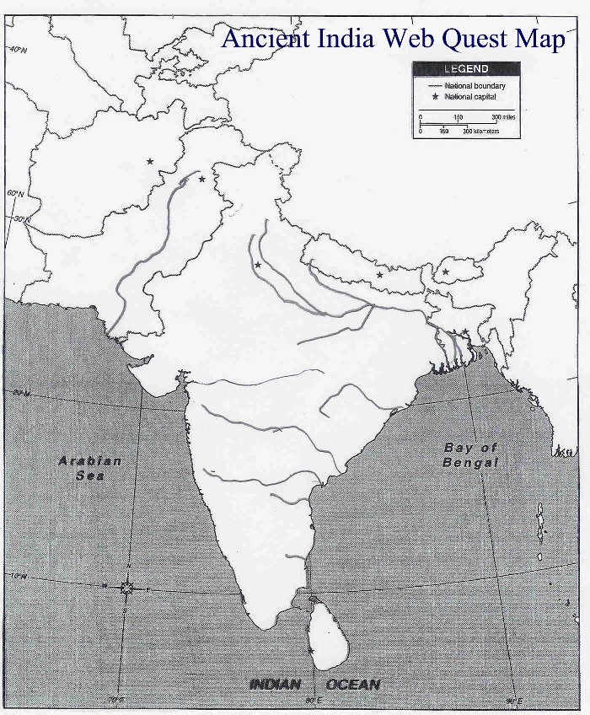
Arrival Dates: June 15th
June 1st: July 1st
June 5th July 15th
June 10th August 1st

Side II: Shade the flood plain along the banks of the Nile River

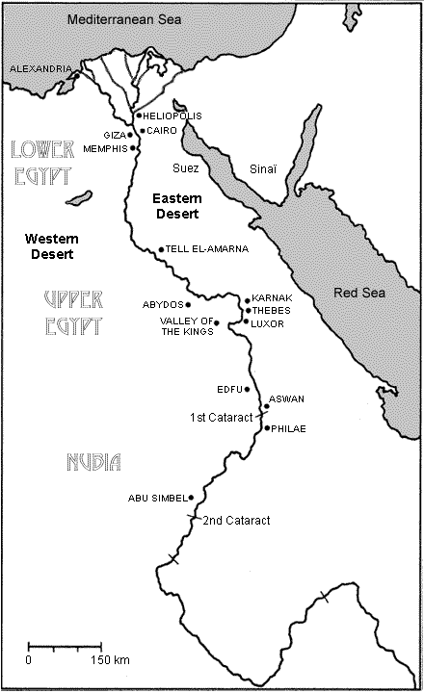

Indra and the monsoons
According to the Vedas, there are three main deities- Agni, Indra and Surya. Agni or Fire is the lord of the Earth, Surya or Sun is the lord of the Sky and Indra is the lord of the region between the Earth and the Sky. In the Vedic period, Indra is the most popular deity and is called the King of the gods. Indra’s weapons are the thunderbolt and lightning and he is the harbinger of the rains, which renders the earth fruitful.
To the Vedic people, the clouds that the winds brought from the ocean were enemies who held the treasures (rain) steadfast to themselves, until they were conquered by Indra and forced to pour them upon the parched soil.
One of the greatest deeds performed by Indra is to release the waters held captive by the demons. According to the myth, the earth is scorched and dry because the rain clouds have been imprisoned by the demon of drought known as Vritra or Sushna. On hearing the pleas of the people, Indra descends from his abode in the sky and is offered Soma, an intoxicating drink which is a favourite of Indra. Pleased with his reception, Indra asks the people how he can be of help. Hearing of their plight, he decides to fight the demons and rescue the rains. A graphic description of the battle details the commencement of the rainy season. At last the conflict is over, the rains descend and the earth is made fruitful.
Match the highlighted word from the text with the synonyms in the box below

Fron earth withhold the genial showers;
Of mortal men the foe malign,
Word | Synonym
 | Struggle
 | To speak evil of
 | Cloudy water
 | Abundant
 | Split or divided

And rival of the race divine;
Whose demon hosts from age to age
With Indra war unceasing wage;
Who, time unnumbered crushed and slain,
Is ever newly born again,
And evermore renews the strife
In which again he forgeits life.

And soon the knell of Vritra’s doom
Was sounded by the clang and boom
Of Indra’s iron shower.
Pierced, cloven, crushed with horrid yell,
The dying deamon headlong fell
Down from his cloud-built tower.
Comprehension:
What happened after Indra defeated Vritra?

How did this affect the Earth?
Now bound by Sushna’s spell no more
The clouds discharge their liquid store;
And long by torrid sunbeams baked
The plains by their copious showers are slaked
The rivers swell, and seaward sweep
Their turbid torrents broad and deep
The peasant views with deep delight,
And thankful heart the auspicious sight.
His leafless fields so sere and sad,
Will soon with waving crops be glad;
And mother Earth, now brown and bare,
A robe of brilliant green will wear.
Hymn to the Nile, c. 2100 BCE
Hail to thee, O Nile! Who manifests thyself over this land, and comes to give life to Egypt! Mysterious is thy issuing forth from the darkness, on this day whereon it is celebrated! Watering the orchards created by Re, to cause all the cattle to live, you give the earth to drink, inexhaustible one! Path that descends from the sky, loving the bread of Seb and the first-fruits of Nepera, You cause the workshops of Ptah to prosper!
Lord of the fish, during the inundation, no bird alights on the crops. You create the grain, you bring forth the barley, assuring perpetuity to the temples. If you cease your toil and your work, then all that exists is in anguish. If the gods suffer in heaven, then the faces of men waste away.
Then He torments the flocks of Egypt, and great and small are in agony. But all is changed for mankind when He comes; He is endowed with the qualities of Nun. If He shines, the earth is joyous, every stomach is full of rejoicing, every spine is happy, every jaw-bone crushes (its food).
He brings the offerings, as chief of provisioning; He is the creator of all good things, as master of energy, full of sweetness in his choice. If offerings are made it is thanks to Him. He brings forth the herbage for the flocks, and sees that each god receives his sacrifices. All that depends on Him is a precious incense. He spreads himself over Egypt, filling the granaries, renewing the marts, watching over the goods of the unhappy.
Where misery existed, joy manifests itself; all beasts rejoice. The children of Sobek, the sons of Neith, the cycle of the gods which dwells in him, are prosperous. No more reservoirs for watering the fields! He makes mankind valiant, enriching some, bestowing his love on others. None commands at the same time as himself. He creates the offerings without the aid of Neith, making mankind for himself with multiform care.
O inundation of the Nile, offerings are made unto you, men are immolated to you, great festivals are instituted for you. Birds are sacrificed to you, gazelles are taken for you in the mountain, pure flames are prepared for you. Sacrifice is metle to every god as it is made to the Nile. The Nile has made its retreats in Southern Egypt, its name is not known beyond the Tuau. The god manifests not his forms, He baffles all conception.
Match the highlighted word from the text with the synonyms in the box below
Word | Synonym
 | Created
 | Grasses
 | Brave
 | Given/Gifted
 | Endless
 | Flood
 | Success
Men exalt him like the cycle of the gods, they dread him who creates the heat, even him who has made his son the universal master in order to give prosperity to Egypt. Come (and) prosper! Come (and) prosper! O Nile, come (and) prosper! O you who make men to live through his flocks and his flocks through his orchards! Come (and) prosper, come, O Nile, come (and) prosper!
Comprehension:
What are 3 things the flooding Nile brings to Egypt?

Indra and the monsoons
According to the Vedas, there are three main deities- Agni, Indra and Surya. Agni or Fire is the lord of the Earth, Surya or Sun is the lord of the Sky and Indra is the lord of the region between the Earth and the Sky. In the Vedic period, Indra is the most popular deity and is called the King of the gods. Indra’s weapons are the thunderbolt and lightning and he is the harbinger of the rains, which renders the earth fruitful.
To the Vedic people, the clouds that the winds brought from the ocean were enemies who held the treasures (rain) steadfast to themselves, until they were conquered by Indra and forced to pour them upon the parched soil.
One of the greatest deeds performed by Indra is to release the waters held captive by the demons. According to the myth, the earth is scorched and dry because the rain clouds have been imprisoned by the demon of drought known as Vritra or Sushna. On hearing the pleas of the people, Indra descends from his abode in the sky and is offered Soma, an intoxicating drink which is a favourite of Indra. Pleased with his reception, Indra asks the people how he can be of help. Hearing of their plight, he decides to fight the demons and rescue the rains. A graphic description of the battle details the commencement of the rainy season. At last the conflict is over, the rains descend and the earth is made fruitful.
Match the highlighted word from the text with the synonyms in the box below

Fron earth withhold the genial showers;
Word | Synonym
 | Struggle
 | To speak evil of
 | Cloudy water
 | Abundant
 | Split or divided

Of mortal men the foe malign,
And rival of the race divine;
Whose demon hosts from age to age
With Indra war unceasing wage;
Who, time unnumbered crushed and slain,
Is ever newly born again,
And evermore renews the strife
In which again he forgeits life.

And soon the knell of Vritra’s doom
Was sounded by the clang and boom
Of Indra’s iron shower.
Pierced, cloven, crushed with horrid yell,
The dying deamon headlong fell
Down from his cloud-built tower.
Comprehension:
What happened after Indra defeated Vritra?

How did this affect the Earth?
Now bound by Sushna’s spell no more
The clouds discharge their liquid store;
And long by torrid sunbeams baked
The plains by their copious showers are slaked
The rivers swell, and seaward sweep
Their turbid torrents broad and deep
The peasant views with deep delight,
And thankful heart the auspicious sight.
His leafless fields so sere and sad,
Will soon with waving crops be glad;
And mother Earth, now brown and bare,
A robe of brilliant green will wear.
Hymn to the Nile, c. 2100 BCE
Hail to thee, O Nile! Who manifests thyself over this land, and comes to give life to Egypt! Mysterious is thy issuing forth from the darkness, on this day whereon it is celebrated! Watering the orchards created by Re, to cause all the cattle to live, you give the earth to drink, inexhaustible one! Path that descends from the sky, loving the bread of Seb and the first-fruits of Nepera, You cause the workshops of Ptah to prosper!
Lord of the fish, during the inundation, no bird alights on the crops. You create the grain, you bring forth the barley, assuring perpetuity to the temples. If you cease your toil and your work, then all that exists is in anguish. If the gods suffer in heaven, then the faces of men waste away.
Then He torments the flocks of Egypt, and great and small are in agony. But all is changed for mankind when He comes; He is endowed with the qualities of Nun. If He shines, the earth is joyous, every stomach is full of rejoicing, every spine is happy, every jaw-bone crushes (its food).
He brings the offerings, as chief of provisioning; He is the creator of all good things, as master of energy, full of sweetness in his choice. If offerings are made it is thanks to Him. He brings forth the herbage for the flocks, and sees that each god receives his sacrifices. All that depends on Him is a precious incense. He spreads himself over Egypt, filling the granaries, renewing the marts, watching over the goods of the unhappy.
Where misery existed, joy manifests itself; all beasts rejoice. The children of Sobek, the sons of Neith, the cycle of the gods which dwells in him, are prosperous. No more reservoirs for watering the fields! He makes mankind valiant, enriching some, bestowing his love on others. None commands at the same time as himself. He creates the offerings without the aid of Neith, making mankind for himself with multiform care.
O inundation of the Nile, offerings are made unto you, men are immolated to you, great festivals are instituted for you. Birds are sacrificed to you, gazelles are taken for you in the mountain, pure flames are prepared for you. Sacrifice is metle to every god as it is made to the Nile. The Nile has made its retreats in Southern Egypt, its name is not known beyond the Tuau. The god manifests not his forms, He baffles all conception.
Match the highlighted word from the text with the synonyms in the box below
Word | Synonym
 | Created
 | Grasses
 | Brave
 | Given/Gifted
 | Endless
 | Flood
 | Success
Men exalt him like the cycle of the gods, they dread him who creates the heat, even him who has made his son the universal master in order to give prosperity to Egypt. Come (and) prosper! Come (and) prosper! O Nile, come (and) prosper! O you who make men to live through his flocks and his flocks through his orchards! Come (and) prosper, come, O Nile, come (and) prosper!
Comprehension:
What are 3 things the flooding Nile brings to Egypt?

Use the vocabulary from the above charts to complete the following activity.  In each box, illustrate a cartoon or image that shows the meaning of the word. Write a one-sentence caption at the bottom using the word you chose. |  | Example:  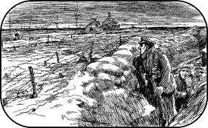  The valiant soldier fought from the trenches in WWI.

Nile Flood India Monsoon
Words or phrases used to describe the Monsoon or Flooding
Words of phrases used to describe the effects of the monsoon or flooding
Similarities
Differences

Conclusion:

