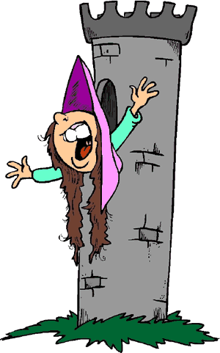
Between Ancient and Modern
In AD 476, warriors attacked the city of Rome and ended more than 800 years of glory for the "Eternal City." Historians mark the fall of Rome as the end of ancient history. The next one thousand years were called the Middle Ages. The Latin term for Middle Ages is "medieval."
The beginning of the Middle Ages is often called the "Dark Ages" because the great civilizations of Greece and Rome had fallen. Life in Western Europe during the Middle Ages was very hard. Very few people could read or write and nobody expected conditions to improve. The only hope for most people during the Middle Ages was their strong belief in Christianity, and the hope that life in heaven would be better than life on earth.
The Dark Ages were anything but dark in other parts of the world. The Muslims in the Middle East and North Africa studied and improved on the works of the ancient Greeks while civilization flourished in sub-Saharan Africa, China, India, and the Americas.
Europe began to experience great change by about 1450. Within one hundred years, Columbus had sailed to America, literacy spread, scientists made great discoveries, and artists created work that still inspires us today. Historians call the next period of European history the "Renaissance," or the "rebirth." The Renaissance is the beginning of modern history.

Feudalism
Feudalism was the system of loyalties and protections during the Middle Ages. As the Roman Empire crumbled, emperors granted land to nobles in exchange for their loyalty. These lands eventually developed into manors. A manor is the land owned by a noble and everything on it. A typical manor consisted of a castle, a small village, and farmland.
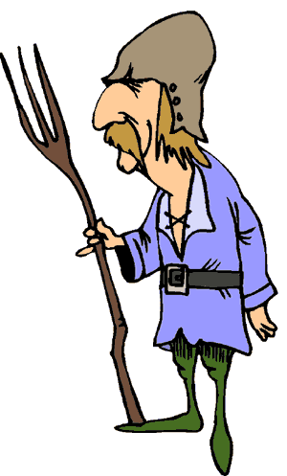
During the Middle Ages, peasants could no longer count on the Roman army to protect them. German, Viking and Magyar tribes overran homes and farms throughout Europe. The peasants turned to the landowners, often called lords, to protect them. Some peasants remained free, but many became serfs. A serf was bound to the land. He could not leave without buying his freedom, an unlikely occurrence in the Middle Ages. Life for a serf was not much better than the life of a slave. The only difference was that a serf could not be sold to another manor.
Serfs would often have to work three or four days a week for the lord as rent. They would spend the rest of their week growing crops to feed their families. Other serfs worked as sharecroppers. A sharecropper would be required to turn over most of what he grew in order to be able to live on the land.

Primogeniture
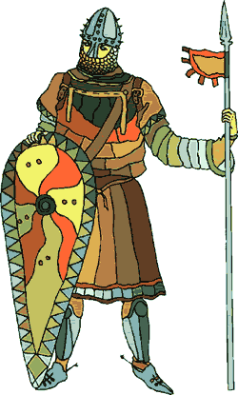
Primogeniture is a system of inheritance where all property is handed down to the first-born son. During the Middle Ages in Western Europe, the oldest son the Lord of the Manor would become the Lord himself upon the death of his father, much in the same way that the oldest son of a king would gain the crown. The younger sons would have to find other careers.
The military was an option for many sons. A knight began his training as a young boy and advanced to the rank of squire at about the age of fifteen. When the overlord considered the young squire worthy, he was proclaimed a knight, and was entitled to the honorific title "Sir." Knights were expected to be chivalrous. Chivalry was a set of rules for honorable behavior followed by the knights. The term chivalry now refers to aristocratic display and public ceremony rather than good manners.
A third option was to acquire a trade. There were no trade schools in the Middle Ages. A father would pay a master to teach his son a trade. The boy would become an apprentice and often live with the family of the master tradesman. After a period of about seven years, the boy became a journeyman. He could now work in his trade and be paid for his work. If a journeyman were an expert in his trade, he might create a masterpiece and become a master himself, able to employ apprentices of his own.
A young woman might look toward marriage in her future. A dowry was a present of money, goods, or sometimes land given by a bride's father to her husband. The dowry, however, was for his use, not hers. A dowry was thought to make a young girl more attractive to a potential husband. A large dowry might make it possible for a young lady to attract a rich landholder. Many girls entered the clergy as nuns, while others worked at servants at the manor house.

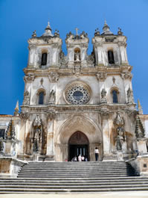
Christendom
By the later Middle Ages, the gods of the Romans, Greeks, and Celts had long since been forgotten, and Christianity became the faith of almost all of the people of Western Europe. People did not think of Europe as a distinct place until after the Middle Ages had passed. Instead they spoke of "Christendom," or the community of Christians. Christianity was the most important influence of the Middle Ages in Western Europe.
Religious life attracted many people during the Middle Ages. The Church was often the only way to get an education. It also allowed poor people to escape a dreary life and possibly rise to power. Religious workers are called clergy. In the Middle Ages, the Pope ruled the Christian Church in Western Europe. Other clergy included bishops, priests, nuns, and monks.
Monks were men who lived in monasteries. Monasteries were small communities of religious workers. Monks devoted their lives to prayer, and their behavior influenced the entire church. Monasteries produced many well-educated men prepared to serve as administrators for uneducated kings and lords. Monks were responsible for keeping the Greek and Latin "classical" cultures alive. Monks also copied books by hand in an era before the printing press. Though few in number, monks played a significant role in the Middle Ages.

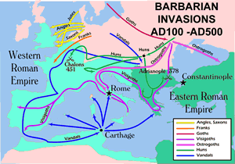
The Barbarians
The Romans saw themselves as having a highly advanced civilization, and they looked down on the cultures of the people who lived beyond the borders of their empire. In AD122, Emperor Hadrian built a wall separating the Roman part of Britain from the mountainous land now called Scotland. The Romans called the Scottish people "barbarians," possibly because the Scot's native Celtic language sounded to the Romans like the bleating of sheep. The term was eventually used to describe anyone who lived beyond the borders of the Roman Empire.
The people who lived northeast of the Roman Empire spoke languages similar to modern German. These "Germanic tribes" included the Vandals, Lombards, Alamanni, Goths, Franks, and Burgundians. Most of the tribesmen did not know how to read, but unlike the Huns, they tended to farms and were not nomadic. By the Middle Ages, most of the Germanic tribes gave up their pagan beliefs and became Christians.
In 376, the Huns forced the Visigoths (western Goths) to leave their homeland near the Danube River in modern Austria. The Visigoths asked Emperor Valens permission to settle inside the Roman Empire. Valens agreed, but charged the Visigoths unfair prices for food and other supplies. When the Visigoths protested, Valens ordered them to leave. The Visigoths refused, and formed an army that defeated and killed the emperor in 378.
Alaric was a Visigoth who joined the Roman army and rose to a high rank. Alaric left the army to became king of the Visigoths when his father died. In 410, the Romans refused to pay a bribe, so Alaric's soldiers formed a siege around Rome. When the city was close to starvation, the Roman citizens opened the gates and allowed the conquering army to enter. The Visigoths rampaged through the streets for three days, pillaging and burning the city. Alaric ordered his army not to molest women or destroy churches. Rome was not completely destroyed, but for the first time in nearly 800 years, the "Eternal City" had been defeated.
Germanic tribes overran what was left of the Roman Empire. The Ostrogoths, or "eastern Goths," came from land we know call the Ukraine. The Ostrogoths conquered most of Italy, Greece, and the western Balkans. The Vandals took control of the Roman territory in North Africa. The Franks overran France, while the Saxons conquered the southern part of England.

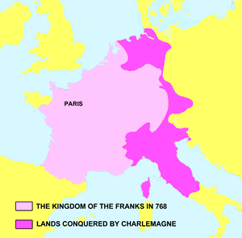
Charlemagne and the Franks
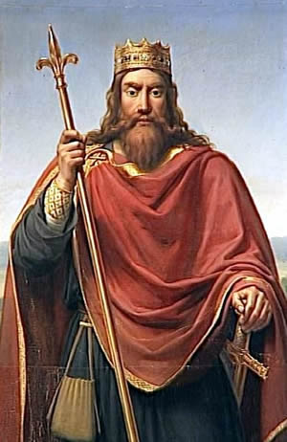
In 486, a warrior named Clovis defeated the Romans and established a kingdom centered in Paris. Clovis was a Frank, one of the many Germanic tribes that lived in Western Europe in the fifth century. Clovis worshipped pagan gods, in fact, his people believed Clovis to be the descendent of Wotan, the most powerful of the Frankish gods. In 496, Clovis and his soldiers fought another Germanic tribe. As the battle turned against Clovis, the Frankish king vowed to devote his life to Christianity if the Franks won the battle. After their unlikely victory, Clovis and 3000 of his soldiers were baptized by a Catholic bishop. Clovis and his soldiers established the power of the Franks and Christianity throughout their realm.
Islamic warriors crossed the Pyrenees Mountains in 732 and attempted to conquer the Franks. A Frankish general named Charles Martel defeated the Muslim army. This victory is considered the beginning of the reqonquista. The reconquista was the Christian reconquest of Europe after the invasion of the Moors.
Charlemagne, a name that means Charles the Great, was Charles Martel's grandson and the greatest of the Frankish kings. In an era when most men were little more than five feet tall, Charlemagne stood six feet, four inches. Charlemagne expanded the kingdom of the Franks into Spain and Central Europe. Although Charlemagne never learned to read or write, he wanted to recapture the glory of the Roman Empire. The Frankish king set up schools throughout his empire and provided funds that allowed monks to copy the works of Greek and Roman authors.
Charlemagne's goal was to unite all of the Germanic tribes into a single Christian kingdom. In 799, Charlemagne's armies rescued Pope Leo III from an attack. On Christmas Day, 800, the pope repaid the king for his assistance. As Charlemagne rose from prayer, Leo placed a crown on Charlemagne's head and proclaimed him "Augustus," emperor of the "Holy Roman Empire." The coronation united Christendom under Charlemagne's rule, but it also troubled the newly crowned emperor. Charlemagne was not prepared for his coronation and may not have wanted to be crowned by the Pope. If the Pope had the power to crown Charlemagne king, the Pope might also have the right to remove the crown. When Charlemagne named his son as his successor, he presided over the ceremony himself and did not invite the Pope. Many years later, as Napoleon was about to be crowned Emperor of France in 1804, he took the crown from Pope Pius VII and set it on his head himself.
Charlemagne's empire crumbled soon after his death, and the promise of returning the glory of Rome to Western Europe soon faded. The term Holy Roman Empire would be used to describe different Frankish and German lands for another ten centuries, but the empire never attained Charlemagne's promise of uniting Christendom into one kingdom. In 1806, Napoleon prepared to oust Francis II from his title as Holy Roman Emperor, so Francis renounced his title and decreed himself emperor of Austria. The Holy Roman Empire then ceased to exist after having been a part of Europe for more than a millennium.

The Vikings
The Vikings were fierce warriors that threatened the security of Charlemagne's empire. The Vikings came from Norway, Sweden, and Denmark, lands we now call Scandinavia. The Vikings were skilled sailors whose advanced methods of shipbuilding gave them an advantage over other Europeans. The largest Viking ships could hold as many as 100 sailors and travel at high speed. Viking ships required a depth of only three feet, so they could be used on rivers to travel inland. The Viking ships were strong enough to withstand the fury of the sea, but light enough to be carried around waterfalls.
The Vikings used their sailing skills to attack without warning and quickly escape. At first they attacked and left with as much as they could carry. Later, they settled down and colonized areas they conquered. By the tenth century, the Vikings controlled parts of Britain, France, and Russia, and raided lands as far away as Egypt.
Other Vikings sailed west and discovered Iceland. About 980, Erik the Red sailed further west and began a settlement on ice-covered land he called Greenland. Viking legends indicate that Erik’s son, Leif Eriksson, reached North America. The Vikings called their settlement Vinland, or “land of the grapes.” We don’t know the exact location of Vinland, but archaeologists found Viking weapons and tools in Newfoundland, Canada. The Vikings abandoned their settlements after about 35 years. Many historians suggest that Christopher Columbus heard the legends of the Vikings and knew of the possibility of a “New World” when he set sail to find Asia in 1492.

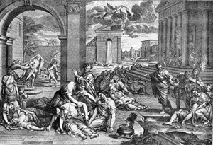
The Black Death
A Great Plague killed nearly half of the people of Europe during in the fourteenth century. A plague is a widespread illness. The plague was also known as "the Black Death" because of the black spots that formed on the skin of diseased people. The devastation of the plague brought great changes to Europe.
The sickness apparently began in Central Asia. In 1347, Italian merchant ships returned from the Black Sea, one of the links along the trade route between Europe and China. The ships were dirty and infested with rats. Fleas living on the blood of infected rats transferred the disease to the seamen. Many of the sailors were already dying of the plague as the infected ships returned to port, and within days of an infected ship's arrival, the disease spread from the port cities to the surrounding countryside. The plague reached Spain, France, England and Russia within three years. Although it is impossible to calculate exactly how many people died from the plague, evidence suggests that it claimed the lives of as many as 25 million Europeans.
The first sign of the plague was often an ache in the limbs. The lymph nodes would then swell. The lymph nodes are glands found in the neck, armpits, and groin. The swelling continued for three or four days until the lymph nodes burst. The illness is often called the Bubonic Plague. Buboes is a Greek word that refers to swollen glands.
The swiftness of the disease, the enormous pain and the grotesque appearance of its victims served to make the plague especially terrifying. Death from the plague was horrible, but swift. The Italian writer Boccaccio said victims often "ate lunch with their friends, and ate dinner with their ancestors in paradise."
Europeans were susceptible to disease because many people lived in crowded surroundings in an era when personal hygiene was not considered important. The Europeans often ate stale or diseased meat because refrigeration had not yet been invented. Fourteenth century medicine in Europe was primitive and unable to remedy an illness that modern technology might have cured. Bad medical advice also advanced the plague. People were advised to not bathe because open skin pores might let in the disease. The devastation of the plague led to advances in medicine. Cities began to build hospitals and enforce standards for sanitation.
Some Europeans believed the plague was a sign from God. Groups known as flagellants tried to atone for the sins of the world by inflicting punishments upon themselves. The flagellants also had a tendency to persecute Jews and even clergymen who spoke out against them. Eccentric and unusual people were often charged with witchcraft and sorcery. Pope Clement VI condemned the flagellants, but they continued to reappear in times of plague.
The Great Plague transformed European society. Entire villages were sickened, forcing the few remaining survivors to move to cities to find work. Labor shortages caused by the death toll led to increased wages. Feudal lands were often converted to grazing because grazing required less labor than farming. The need for a public response to the health crisis led to a weakening of feudalism and the development of more modern government in many places.
The Great Plague continued to affect cities from time to time for hundreds of years. It still exists and is common among rodents. We have a cure for the disease, but occasionally people in isolated places still die from Bubonic Plague.

The Dawn of A New Age
About 1450, European scholars became more interested in studying the world around them. Their art became more true to life. They began to explore new lands. The new age in Europe was eventually called "the Renaissance." Renaissance is a French word that means "rebirth." Historians consider the Renaissance to be the beginning of modern history.
The Renaissance began in northern Italy and then spread through Europe. Italian cities such as Naples, Genoa, and Venice became centers of trade between Europe and the Middle East. Arab scholars preserved the writings of the ancient Greeks in their libraries. When the Italian cities traded with the Arabs, ideas were exchanged along with goods. These ideas, preserved from the ancient past, served as the basis of the Renaissance. When the Byzantine Empire fell to Muslim Turks in 1453, many Christian scholars left Greece for Italy.
The Renaissance was much more than simply studying the work of ancient scholars. It influenced painting, sculpture, and architecture. Paintings became more realistic and focused less often on religious topics. Rich families became patrons and commissioned great art. Artists advanced the Renaissance style of showing nature and depicting the feelings of people. In Britain, there was a flowering in literature and drama that included the plays of William Shakespeare.

Learning and the Arts began to flourish during the Renaissance
- Crusaders returned to Europe with a newfound understanding of the world.
- The invention of the printing press encouraged literacy and helped to spread new ideas.
- Wealthy families and the church had amassed enough wealth to become patrons.
- The development of financial techniques such as bookkeeping and credit allowed merchants to prosper

Humanism
Beginning in the late 1300s, a group of scholars centered in the Italian city-state of Florence began to look to the past for inspiration. These scholars were later called humanists because they stressed human innovation instead of spiritualism. The humanists studied the classics – the works of the ancient Greeks and Romans. In the works of the classics, Renaissance scholars found a way of thinking similar to their own time. They believed this outlook had not been explored since the fall of Greece and Rome.
The humanists recreated classical styles in art, literature, and architecture. Humanists believed that by studying the classics, they could better understand people and the world. The humanists believed in reason. Reason is the ability to think logically. The scholars promoted the investigation of nature, they sought to be clear and articulate in their speaking and writing, and they promoted the responsibility every citizen has to his or her community. In 1459, Battista Guarino wrote, "To each species of creature has been allotted a peculiar and instinctive gift. To horses galloping, to birds flying, comes naturally. To man only is given the desire to learn." The Renaissance humanists valued human experience and believed in the dignity and worth of the individual.
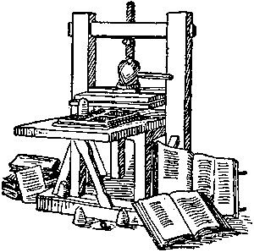
The humanists emphasized the importance of human values instead of religious beliefs. Renaissance humanists were often devout Christians, but their promotion of secular, or non-religious values, often put them at odds with the church. Today we refer to the study of literature, philosophy and art as the humanities. The civilizations of Greece and Rome ended long ago, but those civilizations continue to influence us through the humanities.

Johann Gutenberg
A good cook can take leftovers and turn them into a delicious meal. Like a good cook, Johann Gutenberg took what had already been discovered, and created a small invention that changed history. Gutenberg created a machine that allowed him to move small blocks of letters in such a way that written material could be printed and mass-produced. Few people outside the clergy could read before Guttenberg invented the printing press, but once books became less expensive, literacy spread through Europe.
Block printing existed long before Gutenberg. The Chinese had been carving wood blocks to print books as early as 868, but their process had one major drawback; a new set of woodcuts had to be made for each book. Producing one book was difficult; producing a variety of books was not practical.
Writing ink dates from about 2500 BC in Egypt and China. The earlier cultures took soot from fires and mixed it with sap. Later civilizations used the dark blue indigo plant. Gutenberg used an oil-based printing ink that would last longer than other inks used in his time.
We don't know much about Gutenberg because he was not famous during his lifetime. He was born in Germany about 1400, and worked as a goldsmith. In 1448, Gutenberg developed engraved signatures for each number, letter, and punctuation mark. He then built the molds to hold the signatures in place, and borrowed money to purchase a press. Gutenberg published the first mass-produced book: a 1,282 page Bible. To this day, more copies of the Bible have been printed than any other book.
Copies of Gutenberg's invention spread throughout Europe, but the German goldsmith did not get rich from his invention. Patents did not yet exist, so anybody could build a printing press without compensating Gutenberg for his inspiration. Some religious and government officials denounced the invention of printing because they feared that it would spread bad ideas. But they were a minority. By 1500 there were 1,700 printing presses in Europe. The presses had already produced about 20 million volumes of 40,000 different books.
City-states in Italy
During the Middle Ages, much of Italy was controlled by the Holy Roman Empire. As the emperors and popes fought for control, both were weakened. Several Italian cities formed states that were independent of both the empire and the church. Venice and Florence were two centers of power and wealth that became the cradle of the Renaissance.
Venice was founded in the fifth century by people fleeing from Attila the Hun. They settled on a group of islands on the northeastern edge of the Italian peninsula. Shipbuilding was the primary industry in Venice. During the Crusades, Venetian ships provided transportation to the Holy Land. By the 13th century, Venice was the most prosperous city in Europe. The city became rich by collecting taxes on all merchandise brought into its harbor. Venice built huge warships that protected the valuable cargo of its merchant ships from pirate raids. With the vast wealth from trade, many of the leading families of Venice vied with one another to build the finest palaces or support the work of the greatest artists.
Florence, the “city of flowers,” was located in the hill country of north-central Italy. It prospered because of the wool industry. Sheep were raised in the rock hill country of central Italy, and Florence was a center of wool processing. During most of the Renaissance, wealthy merchants dominated Florence.
The merchants competed with one another by building grand palaces for themselves. The merchants were patrons of the arts. Patron comes from the Latin word for father. They hired artists to fill their homes with beautiful paintings and sculptures. Patrons bought rare books and paid scholars to teach their children. The money and encouragement of patrons together with that of the church made the masterpieces of Renaissance art possible.
The Medicis
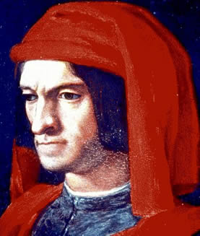
In the 15th century, the leading families of Florence decided they needed a strong person in charge to lead them against the growing threat of rival cities. They chose Cosimo de Medici, a wealthy banker, to take control of the government. Cosimo maintained the appearance of republican government, but he appointed his relatives and people he could control to important positions. When Cosimo died in 1464, his son and grandson continued his policies. The Medici maintained control by exiling people who disagreed with them and encouraging other Italian cities to form alliances with Florence.
The best known of the Medicis was Cosimo’s grandson, Lorenzo, who was known as “Lorenzo the Magnificent.” Lorenzo was not only a shrewd banker and clever politician; he was also a scholar and a poet. Under Lorenzo’s leadership, Florence became one of the most beautiful and prosperous cities in Italy, as well as a center of the Renaissance.
Italian Social Classes
The people of Renaissance Florence, like most city–states of the era, were composed of four social classes. The nobles owned much of the land, and lived on large estates outside the city walls. They behaved according to the rules of chivalry and distained the merchants.
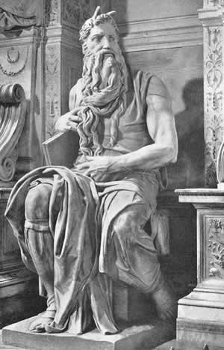
The merchants were the newly rich, who gained wealth in industries like wool processing, boat making and banking. The merchants sought to protect their wealth by controlling the government and marrying into noble families. They became patrons of great artists in order to gain public favor. The middle class of Florence was composed of shopkeepers and professionals
At the lowest level were the workers, who did not have job protection and were very dependent on their employers. Workers who violated rules could have their wages withheld or could be discharged from their jobs. As difficult as their lives were, however, these urban workers were better off than the peasants who lived in rural areas.

Renaissance Art
The Renaissance patrons wanted art that showed joy in human beauty and life's pleasures. Renaissance art is more lifelike than the art of the Middle Ages. Renaissance artists studied perspective, or the differences in the way things look when they are close to something or far away. The Renaissance artists painted in a way that showed these differences. As a result, their paintings seem to have depth.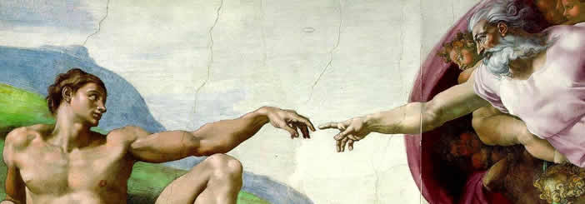
An artist from Florence named Giotto was one of the first to paint in this new style. Giotto lived more than a century before the beginning of the Renaissance, but his paintings show real emotion. The bodies look solid, and the background of his paintings show perspective. The art produced during the Renaissance would build upon Giotto's style.
Leonardo da Vinci was born in 1452 in the village of Vinci. His name means Leonardo of Vinci. Leonardo began his career working for a master painter in Florence. By 1478, Leonardo left his master and set up his own workshop. People have been trying to guess the secret behind the smile of Leonardo's Mona Lisa ever since he painted it about 1505. Leonardo's Last Supper shows clearly the different feelings of Jesus and his followers.
Leonardo's fame grew—but not just for his painting. Leonardo was truly a "Renaissance Man," skilled in many fields. He was a scientist and an inventor as well as an artist. He made notes and drawings of everything he saw. Leonardo invented clever machines, and even designed imitation wings that he hoped would let a person fly like a bird.
Michelangelo Buonarroti of Florence was one of the greatest artists of all time. Like Leonardo, Michelangelo was a "Renaissance Man" of many talents. He was a sculptor, a painter, and an architect. When Michelangelo carved a statue of Moses, he included veins and muscles in the arms and legs.
Michelangelo was a devout Christian, and the church was his greatest patron. He designed the dome of St. Peter's church in Rome. Nearby, Michelangelo's paintings cover the ceiling of the Sistine Chapel, the building where new popes have been selected for more than five hundred years. The ceiling of the Sistine Chapel illustrates the Book of Genesis, with scenes that span from the Creation to the Flood. The project was very difficult. Working alone, Michelangelo had to lie on his back atop high scaffolding while he painted the vast ceiling.
The ideas and techniques of artists such as Giotto, Leonardo and Michelangelo were copied and improved on by other artists and inventors. In time, the Renaissance that began in Italy would spread through Western Europe.
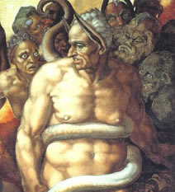
The ceiling of the Sistine Chapel is one of the world’s most famous paintings, but not everyone was happy with Michelangelo’s work. Cardinal Biagio de Cesena noted that the crowd of more than 300 human figures would be more appropriate in a wine shop than in a papal chapel. Michelangelo responded to this criticism by adding a portrait of Biagio among the figures of the damned in the scene of the Last Judgment.
The Renaissance Spreads
The rebirth of the Italian cities attracted visitors from all over western Europe. Merchants and bankers hoped to make their fortunes in the Italian city-states. Artists and students sought knowledge and fame. When these travelers returned home, they brought Renaissance ideas with them. In time, the ideas of the Renaissance influenced people far from the Italian peninsula.
William Shakespeare is the best-known writer of the Renaissance. His plays mixed humor with drama, and showed the strengths and weaknesses of people. Audiences flocked to see his presentations of Roman emperors, British kings and queens, and Italian teenagers.
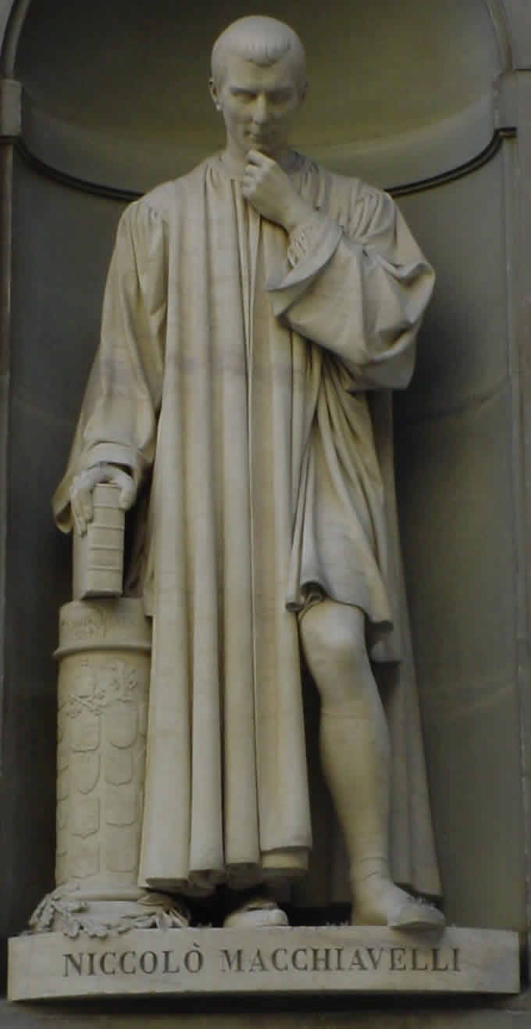
Pieter Bruegel was a Dutch painter who wanted to show people as they really were. Breugal studied Italian art, but he developed his own style. Many of his paintings show peasants working, dancing, and eating.
Niccolo Machiavelli
Niccolo Machiavelli was one of the most influential writers of the Renaissance. He believed Italy could not be united unless its leader was ruthless. In 1513, he wrote The Prince, where he advised rulers to be kind only of it suited their purposes. Otherwise, he warned, it is better to be feared than loved.
“You must know there are two methods of fighting, the one by law, the other by force; the first method is of men, the second of beasts; but because the first is frequently not sufficient, one must have recourse to the second. Therefore it is necessary for a prince to understand how to use the methods of the beast and the man . . . A prince . . . ought to choose the fox and the lion; because the lion cannot defend himself against traps and the fox cannot defend himself against wolves. Therefore, it is necessary to be a fox to discover the traps and a lion to terrify the wolves. Those who rely simply on the lion do not understand this.”
-- Niccolo Machiavelli, The Prince (1513)

