Welcome to your introduction for the monotheistic religion of Judaism.
Judaism actually began in Mesopotamia when people began to travel from there.

Task One:
Begin by watching this video: The Story of Judaism

Task Two:
Read collaboratively through the following slides and react to the questions in the boxes when you see them. Work together as you answer the questions.
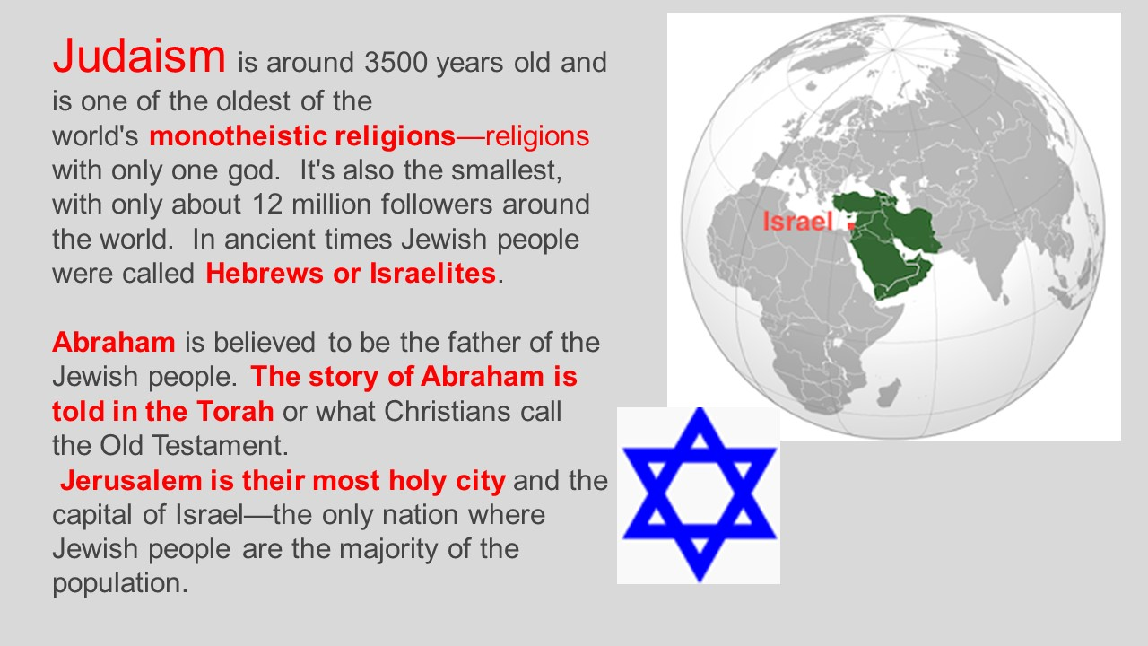
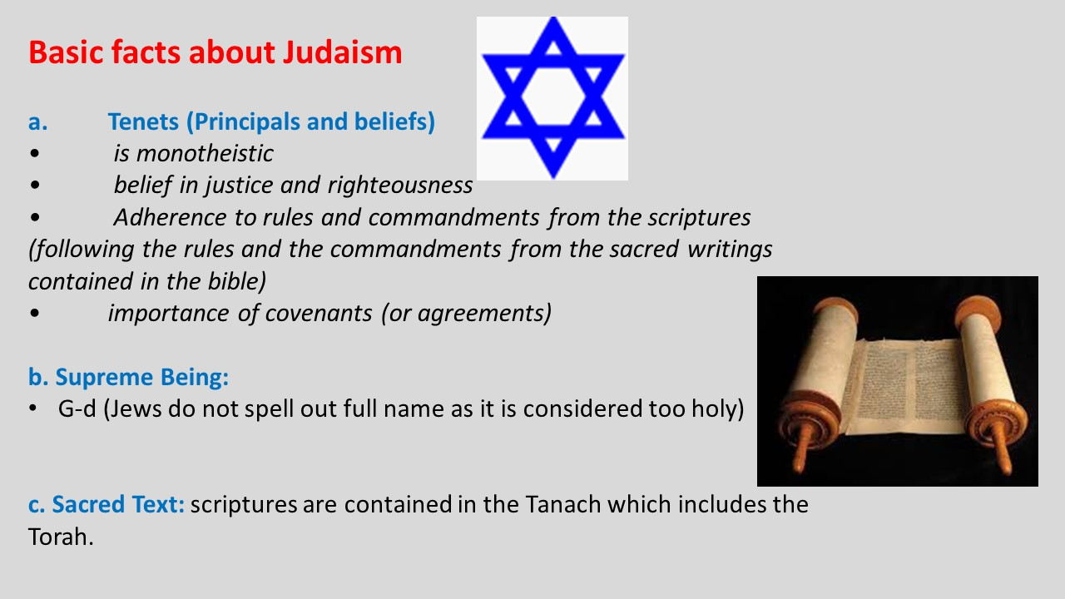
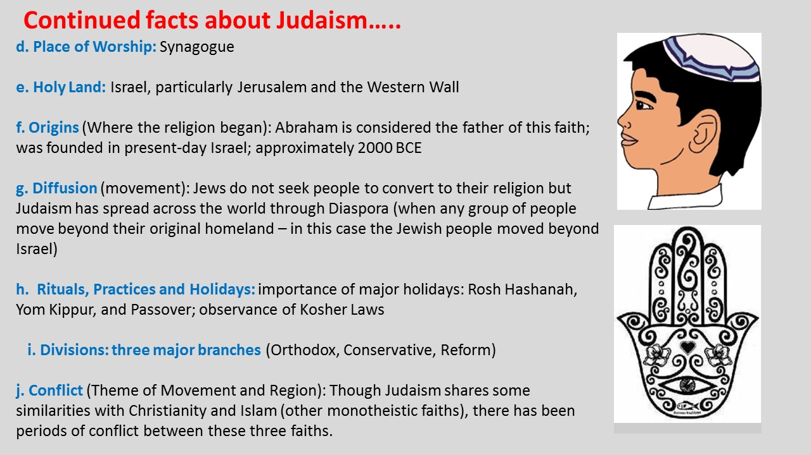

- What are you thinking right now as far as the comparison of this religion to the ones you have studied about so far?

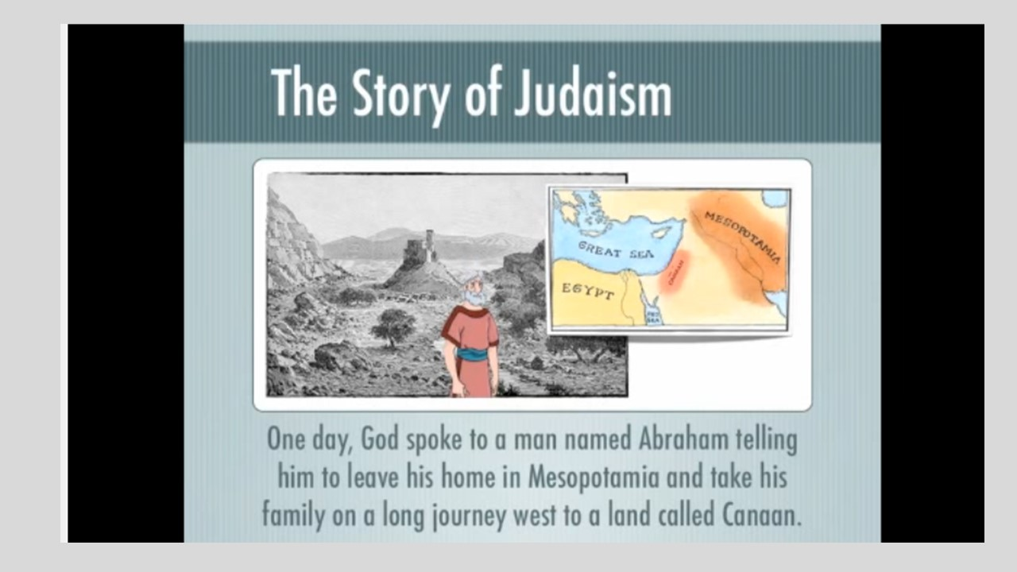
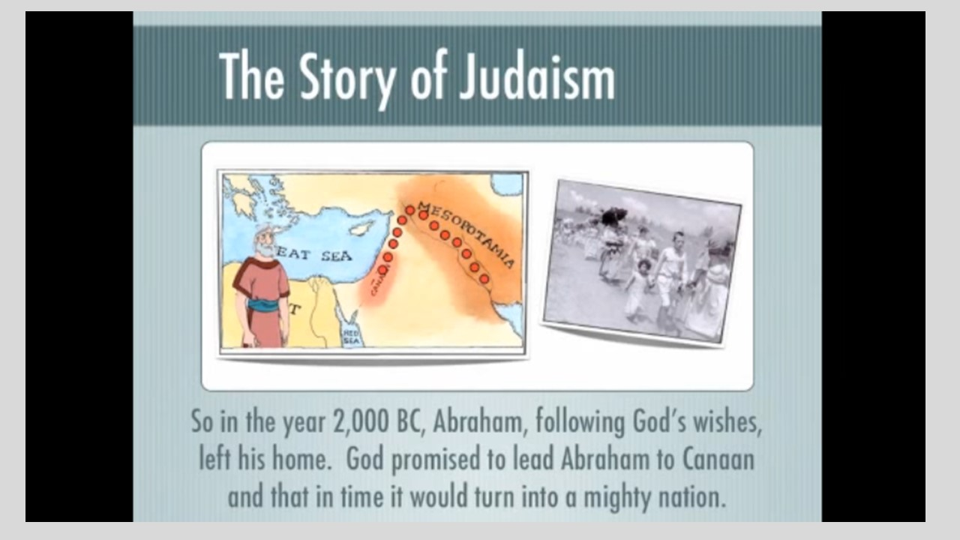

2) After reading the above, what does this remind you of?

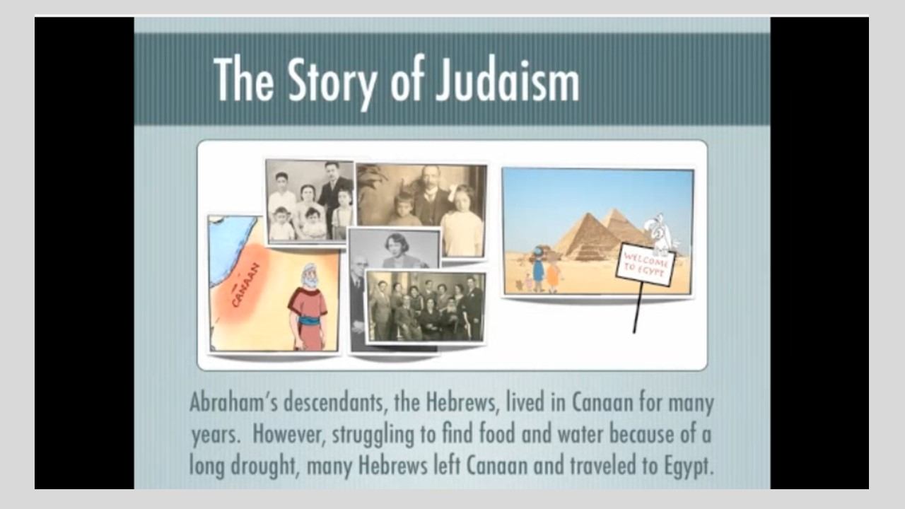
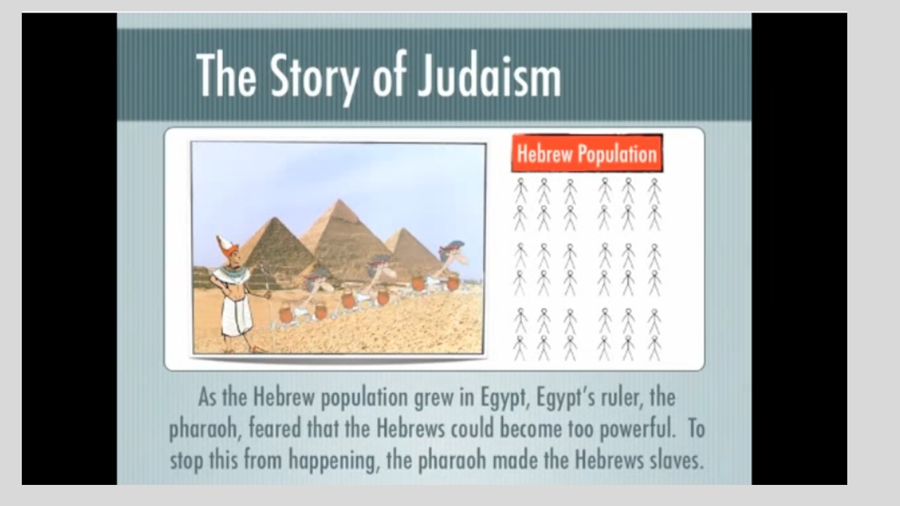

3) After reading this, we are realizing…..

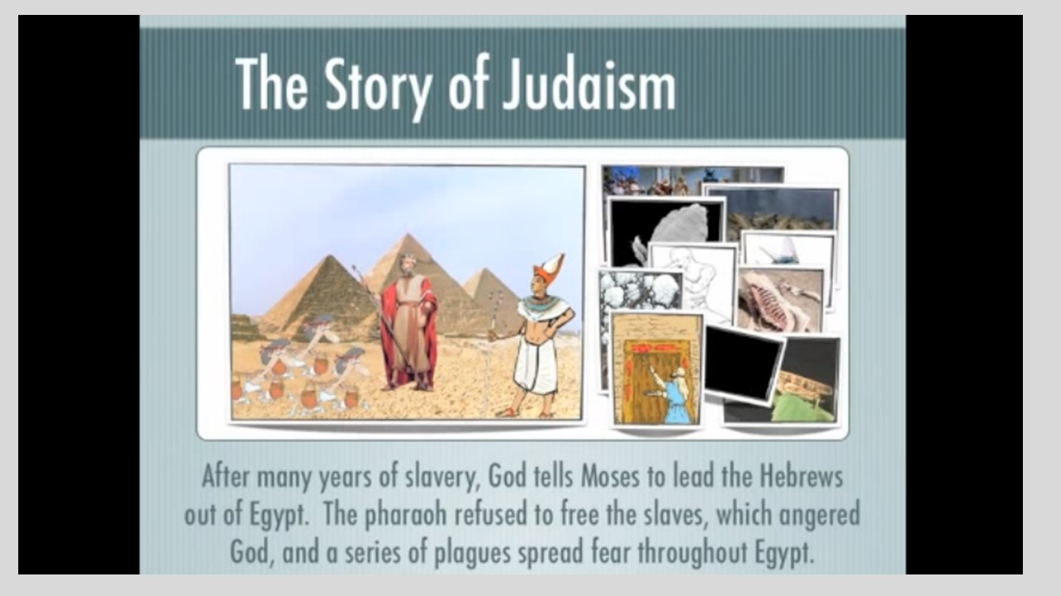
Do you remember the plagues (or deadly diseases) that God sent?

Turning water to blood | frogs | lice | flies | Diseased livestock
Hail and thunder | locusts | darkness | Death of the first born | ??????

4) Our thoughts on what this is saying about power and beliefs and religions and paying consequences……

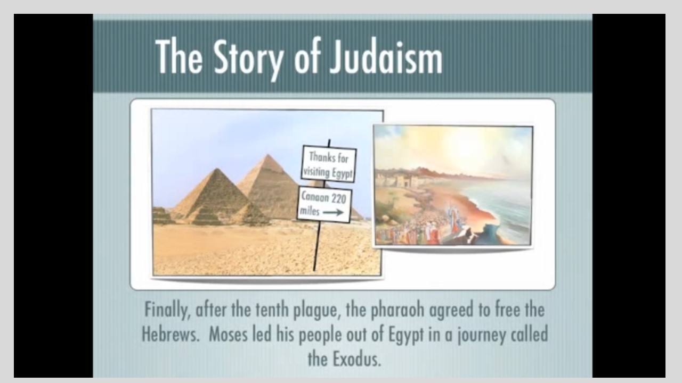
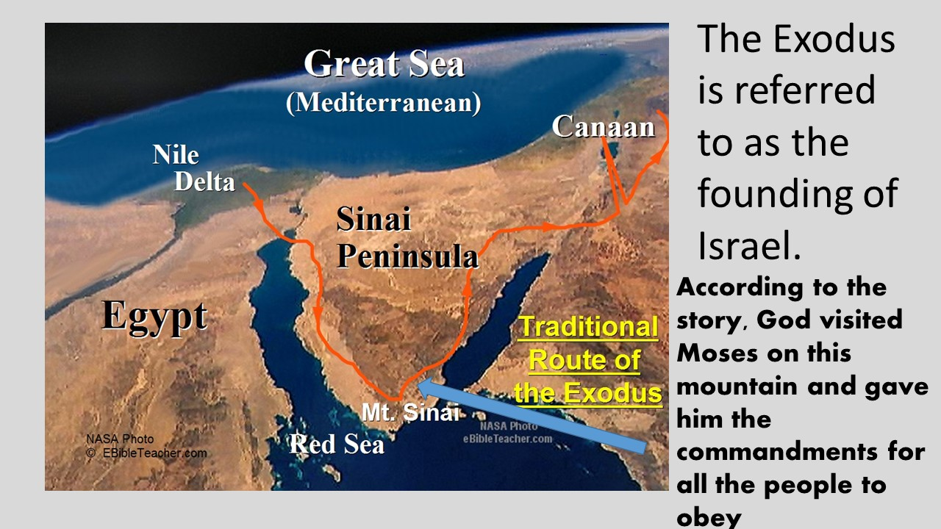
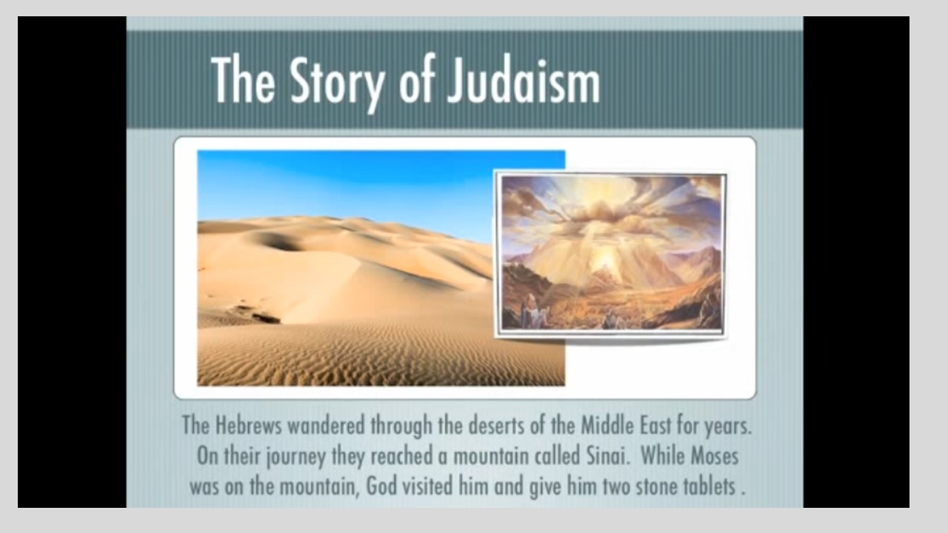
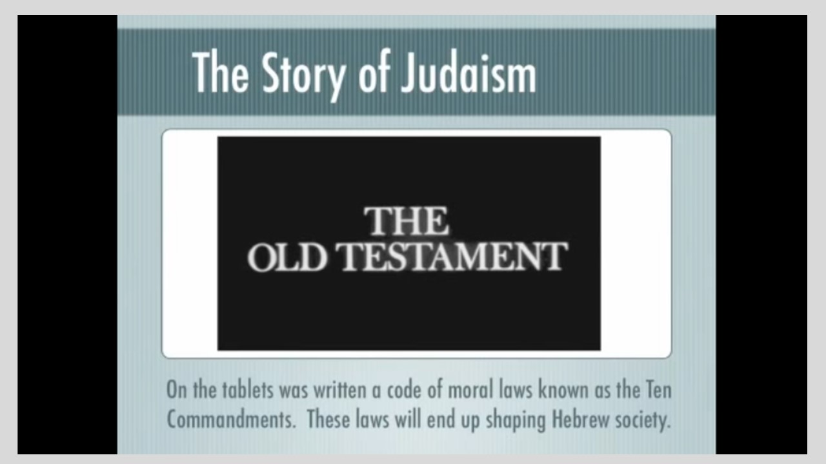

5) Now, we are realizing…..

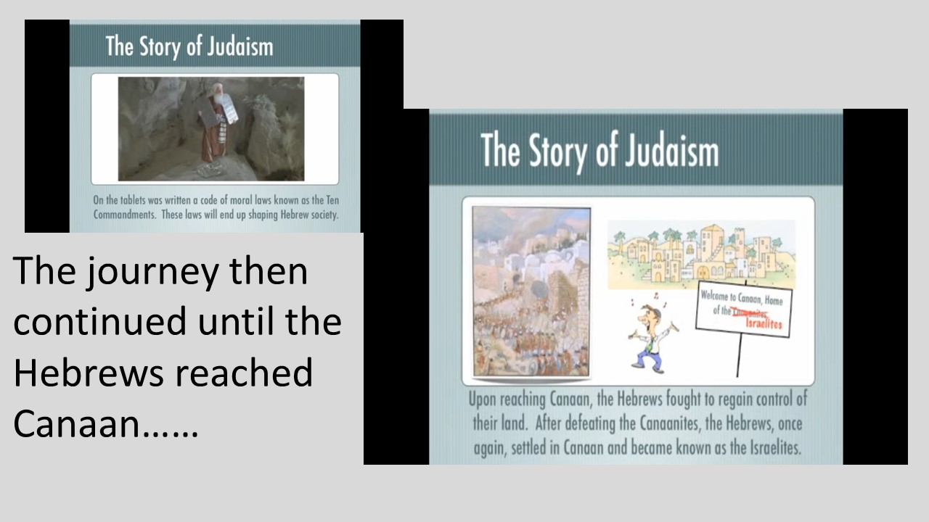
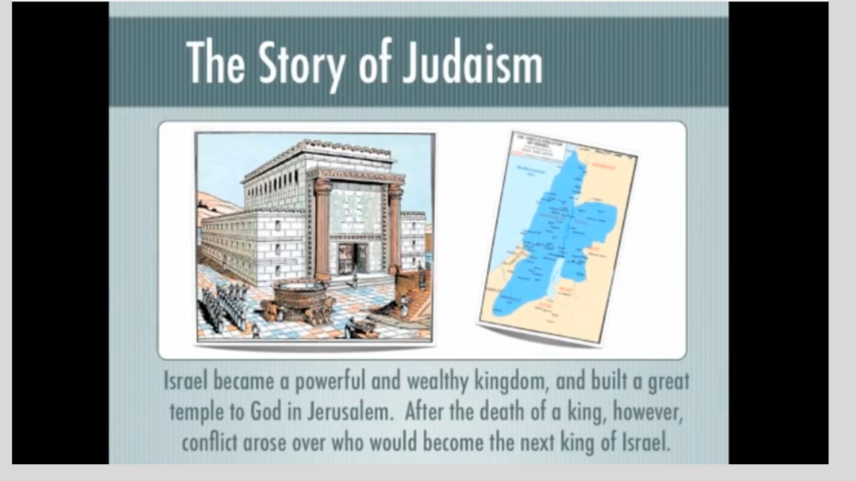

6) We are finding that there is a cause-effect relationship. One thing leads to something else.
Here is what we discovered…..

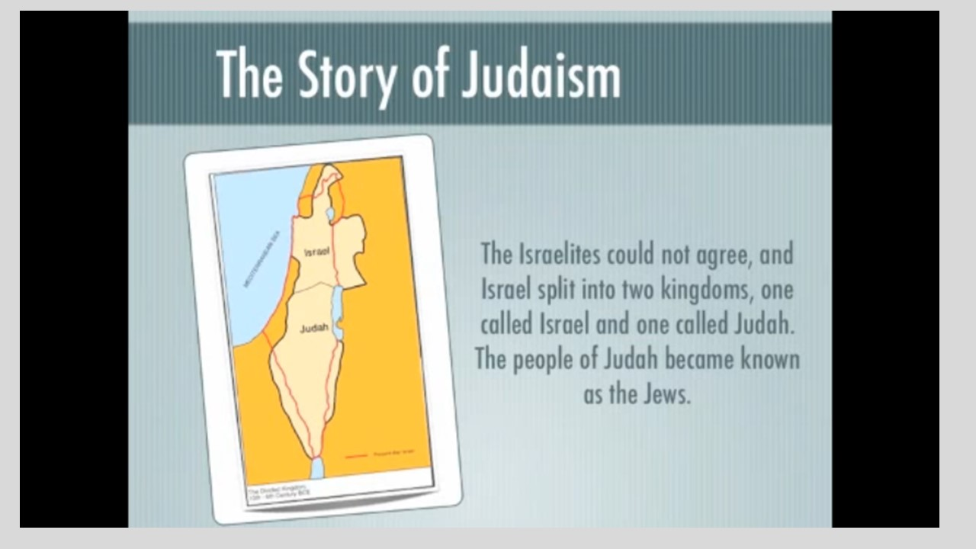
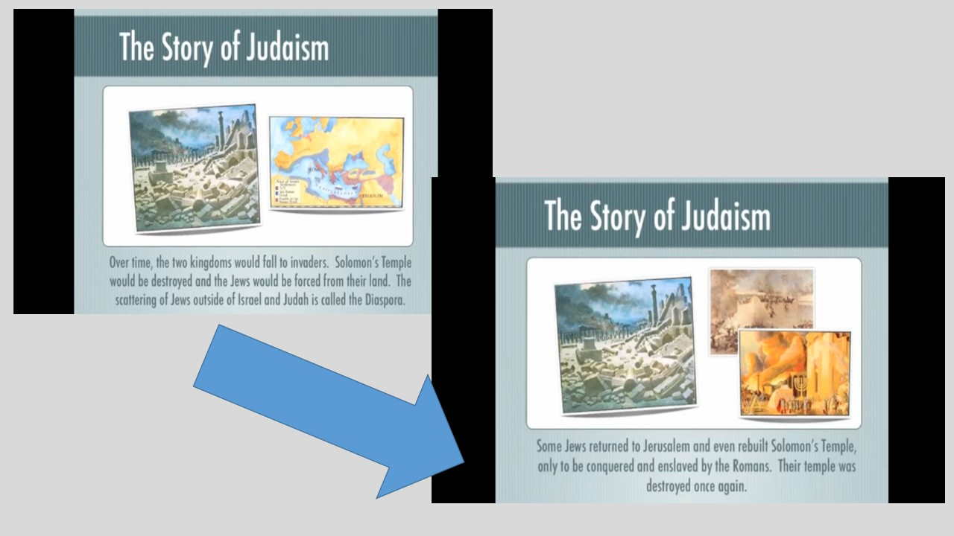
The above slide reads “over time, the two kingdoms would fall to invaders. Solomon’s Temple would be destroyed and the Jews would be forced from their land. The scattering of Jews outside of Israel and Judah is called the DIASPORA. Some Jews returned to Jerusalem and even rebuilt Solomon’s Temple only to be conquered and enslaved by the Romans. Their temple was destroyed once again.

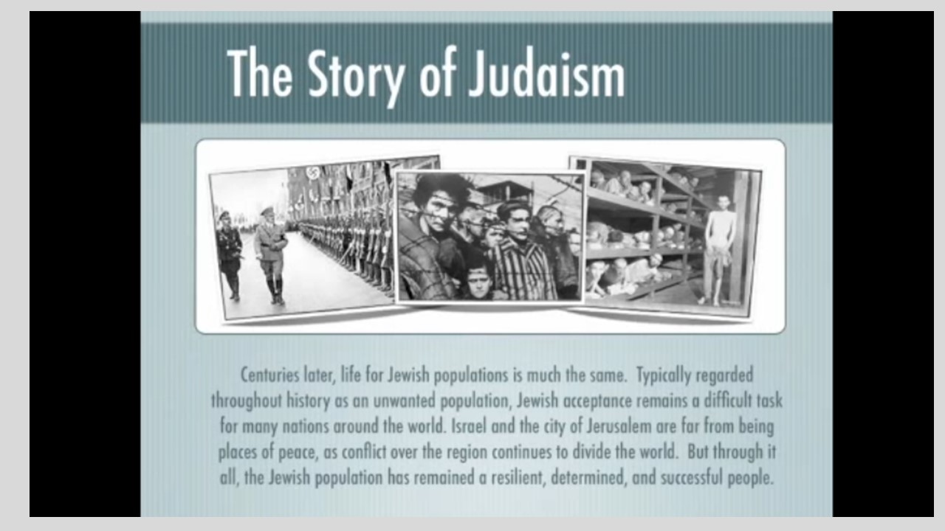

7) We are understanding that all religions, whether they are polytheistic or monotheistic, share these 5 things……
(Explain your 5 things and number them.)

