Name: ________________________

Hero: People who, in the face of dander and adversity, display courage and will self-sacrifice for some greater good.
Part A: Modern Hero vs. Ancient Hero

1) Create a word bank of at least 5 words that describe the characteristics of a modern day “hero”
Modern Day Hero Word bank

2) Create a word bank of at least 5 words that describe the characteristics you believe that the Ancient Greeks would
value in a ancient “hero”
Ancient Greek Hero Word bank

3) Place each word you wrote down and place them in the appropriate location on the Venn diagram.
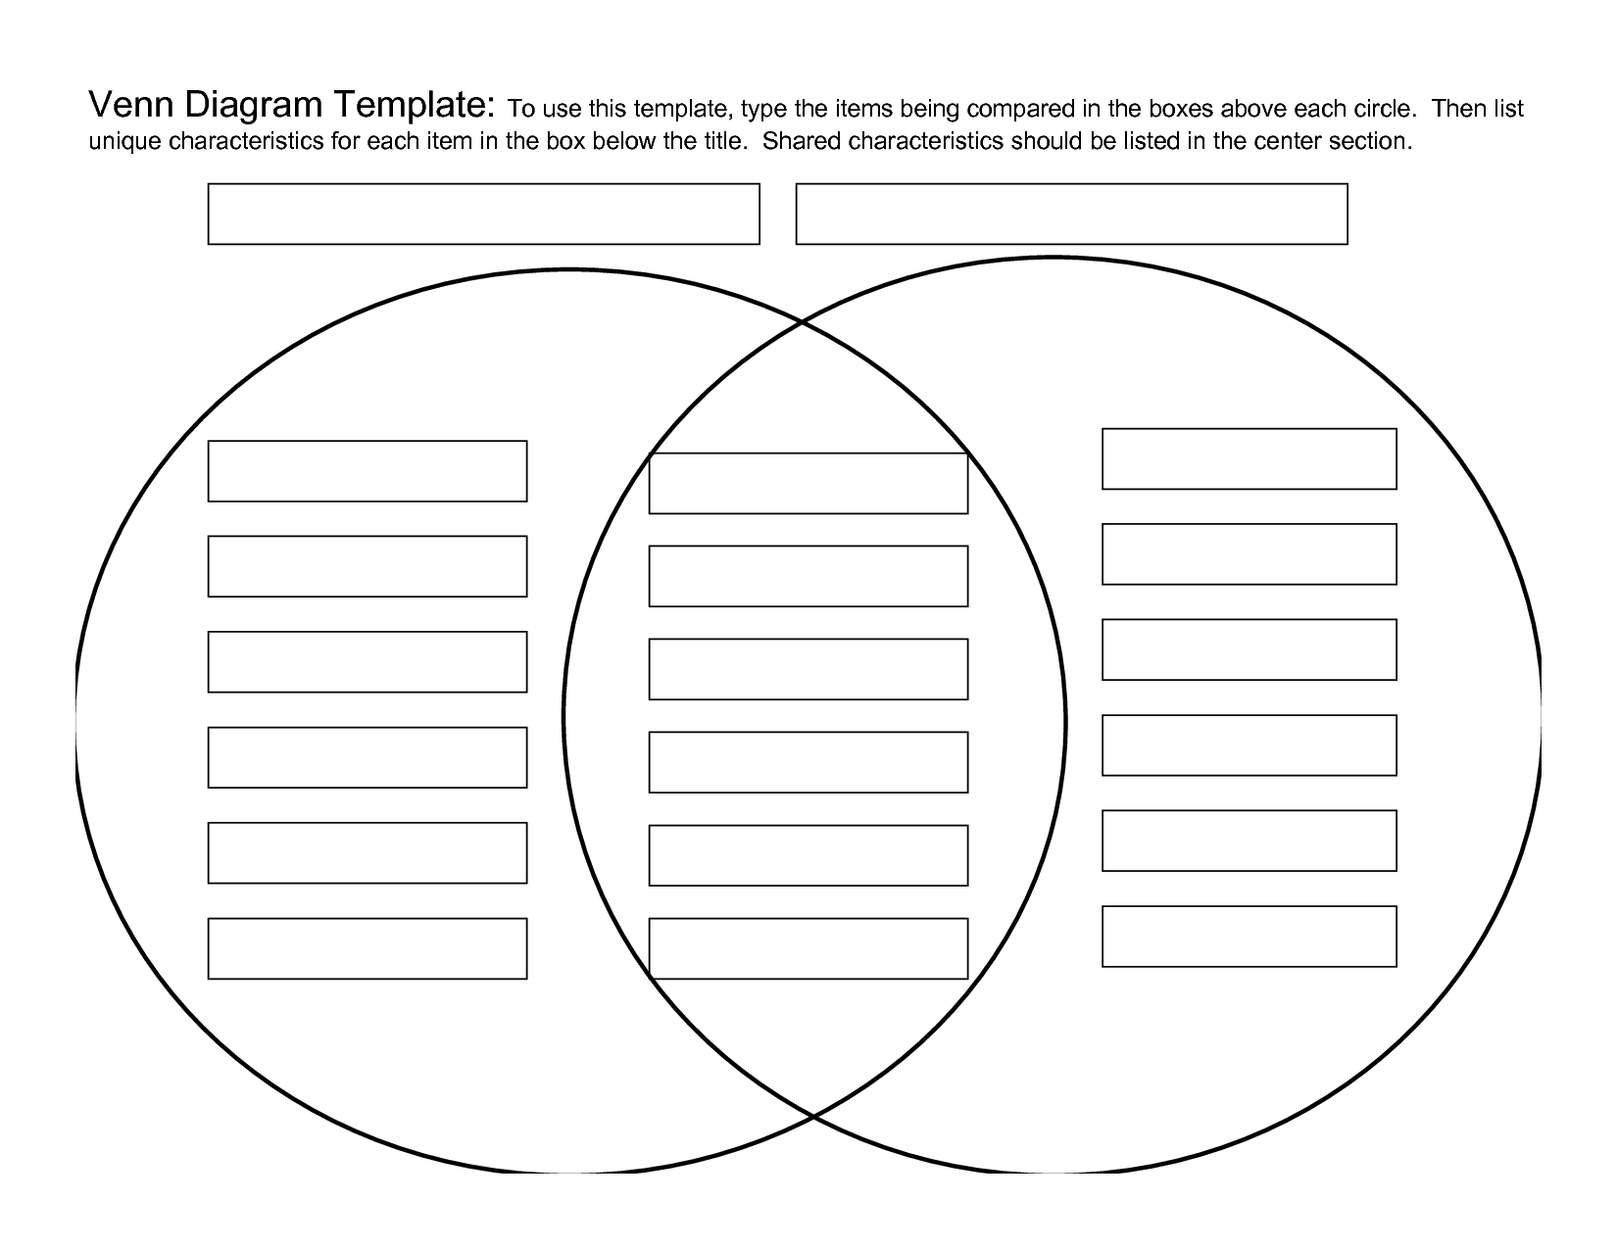

4) Write summary biography about a modern day hero of your choice. Your hero should represent the characteristics
you wrote above. Write a minimum of 1 detailed paragraph with 5 sentences.

5) Write summary biography about an Ancient Greek hero of your choice. This hero should represent the
characteristics you wrote above. Write a minimum of 1 detailed paragraph with 5 sentences.

6) Write a paragraph answering the following open response. Do you believe the Ancient Greeks and modern day
Americans valued the same characteristics in a hero? Why or why not? Provide evidence to support your position.

Part B: Greek Monster vs. Modern-Day Villain

Villains and Monsters: As you have been researching Greek heroes and modern-day superheroes, the idea of the “bad guys”, whether they are mythical creatures or scary villains, in a big part of a hero’s story. The creature or villain that a hero vanquishes is sometimes a reflection of the hero, but often is just something so evil and dark that most readers (viewers) will agree that the hero must defeat. All this said, some villains and monsters are the most interesting part of the story. Choose one Greek monster/creature and one modern-day villain to compare and contrast in the Venn diagram below. Include at least two different details in each of the three different circle areas.

Greek Monster Modern-Day Villain
__________________________________ _____________________________

Part C: Question Reflection

1) What was the role or importance of myths within Ancient Greek Culture?

2) How do we use stories to explain the world around us?

3) Often a myth is used to teach the youth about how to behave through the “moral of the story” style lessons. What tool do modern-day Americans use to teach our youth similar lesson? Provide an example of the tool and a summary of a lesson taught.

Part D: Learning Activity

- Select 1 square from the choices below to finalize our unit on Ancient Greece.
“Extra, Extra, Read all about it!”
Read a Greek myth of your choice. Imagine you are a reporter on the scene. Write an article, include who, what, when, where, and why. Draw illustrations to accompany your article.

“Create a diorama”
Read a Greek myth of your choice. Create a diorama of the climax in that story. Include a brief summary explaining your diorama.

“Write a Play”
Read a Greek Myth of your choice. Rewrite the story into a play. Present the play in class. Remember to include props and costumes.

More options on next page

Draw a comic strip about
one of the Greek heroes
and tell his story through
art. Your comic strip must
have a minimum of 10
frames.

“Make a Trojan Horse”
Read the story of the Trojan Horse. Create a model of the Trojan horse, labeling each part. Write letters to the people of Troy explaining what the horse is and why they should accept the gift. See Mrs. Sheffield for detailed directions on creating the Trojan horse.

“Write an Encomium”
An encomium is a tribute to a mythological hero. In these tributes, which are recited aloud, ancient Greeks related the background, adventures, and admirable qualities of their heroes. Choose a “memorable mortal” or Olympian god or goddess, and write an encomium to recite to the class.

“Mythology in the Marketplace”
Research familiar products or brands that have Greek names. Choose one example to discuss with the class. Identify the character and list the positive qualities with the product. Write a brief statement that explains why you think the manufacturer chose this character to represent the product. Present your findings in a PowerPoint presentation.

Pick a character from the Greek
myths and create a "family tree"
based on the information you
can find about the various gods,
goddesses and heroes who have
passed through your character¹s life.

“Whodunit?”
Many writers tried to blame the Trojan War on one person. Read the story of the golden apple and determine who was to blame. Create a chart with three columns: 1st column is a list of all the characters. The second and third column is where you will give the reasons why the character is guilty and not guilty. Upon completion of the chart, create a wanted poster for the guilty character.

“Let’s Have a Pantheon”
Read a Greek myth of your choice. Present a first-person oral report on a memorable character in Greek mythology. Include the following in your presentation: name (or names) of character, character’s family background, symbols associated with the character, special abilities of character, one episode from the character’s life that illustrates his or her unique characteristics.

Anyone who has spent time in
their local supermarket has seen the latest tabloid headlines: "Rabbit-Faced Baby Born to Buck-Toothed Mom" or "Aliens Abduct Man and Return Him to Earth 100 Years Later." Produce a paper in the style of a tabloid that retells a story of a Greek god or hero.

Hero Project Check Sheet Name:_______________________________
What project square did you choose to complete? _________________________________________________________________________________
Your Project should be evidence of your knowledge of Greek Mythology, and more specifically Ancient Greek Society.
Circle  YES or NO | Are your answers on the packet well thought out responses with full sentences and proper grammar? Is your written response high quality? Would you be proud to read your question reflections to the class?
Circle  YES or NO | Is your project high quality? Would you be proud to show off your work to your parents and have it posted on the wall to show to your peers?
Circle  YES or NO | Does your project show evidence of student learning and understanding of Greek Mythology and Greek culture?
Circle  YES or NO | Does it prove that you took the time to do research on Greek Mythology using more than just 1 source? Does it prove that you read through the available websites on Greek Mythology, rather than just skimming the images?
Circle  YES or NO | Did you research your chosen modern day hero?
Circle  YES or NO | Does your written paragraph on your modern day hero prove that you have an understanding of who that person is and their importance to society or personally in your own life?
Circle  YES or NO | Did you write your question reflections in your own words? If Ms. Gutscher can find evidence of plagiarism (copy and paste or sentences, or wording that is not at your level) then you will be at risk of academic dishonesty.  - Never copy full sections of websites, full paragraphs or even full sentences.  - Read a piece of information and get a good understanding of the material, then without looking write your own summary in your own words.  - Never write down words that you do not know the meaning of, this is the first red flag that your writing is plagiarized. Be sure it is your words, thoughts, and ideas, and not someone else’s.
Circle  YES or NO | Does your project look like it is 6th grade level or above?
Circle  YES or NO | Will the Reader and audience of your project gain any new information on Greek Mythology?
Circle  A C F | What grade do you believe this quality of work deserves?
Circle  A C F | What grade do you predict Ms. Gutscher will give it?

