The First Americans

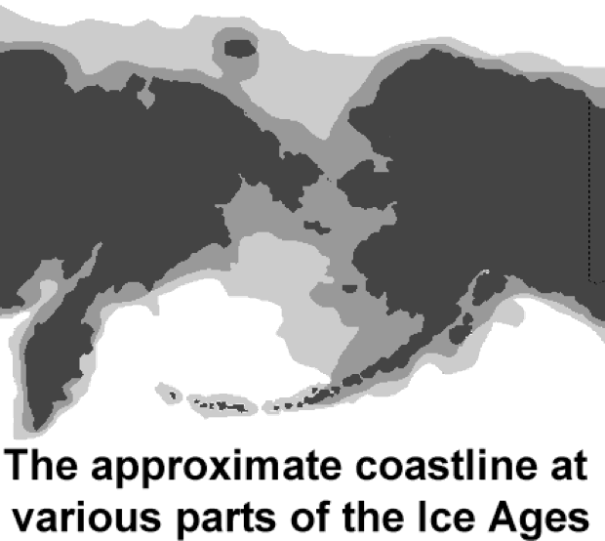Over thousands of years, people spread out from Africa into Europe and Asia. Long before the invention of farming, the wheel or writing, the first hunters reached Beringia. Beringia is a modern name for a strip of land that once connected Asia to Alaska in North America.
The current evidence suggests the first humans crossed this “land bridge” at least 40,000 years ago and perhaps even earlier.
Asia and America have been separated by the Bering Strait for about 15,000 years. The continents are now more than fifty miles apart, but at one time they were connected by a passage more than 1000 miles wide.
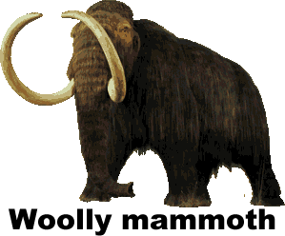Beringia existed during the Ice Ages, periods when the climate of the earth was colder. During an Ice Age, precipitation that fell on land would harden into large masses of ice called glaciers. The forming of glaciers caused sea levels to fall about three hundred feet.
Scientists fear modern industry has made the earth warmer, causing ice at the Polar Regions to melt. These melting ice caps could cause the oceans to rise and coastal lands to be submerged.
Although the climate of Beringia was very cold, it appears to have been warmer than nearby land is today. Beringia was not covered with ice because there was very little snowfall in the region. Instead, Beringia was covered with grass and small trees that fed large mammals such as bears, bison and the now extinct woolly mammoths and mastodons. These animals attracted human hunters to the region. The hunters who crossed Beringia into America came in small groups beginning about 40,000 years ago.
As the earth grew warmer, the glaciers melted and the land bridge slowly closed about 15,000 years ago—this was at least 9000 years before civilizations developed in Egypt, Mesopotamia, and China. Today more than 50 miles of ocean separates Asia from North America.
The Inuit—traditionally known by outsiders as Eskimos—also reached America from Asia, but long after the land bridge had closed. The Inuit crossed the frigid waters of the Bering Strait in boats between 6000 and 2000bce. Their DNA indicates that the Inuit are genetically unrelated to the other indigenous people of America.
Archaeologists are also intrigued with ancient skeletal remains found primarily in South America that do not fit the profile of the people who passed through Beringia. DNA evidence suggests that there may have been some migration to America from the Polynesian Islands of the Pacific, possibly by sailors who were blown off course.
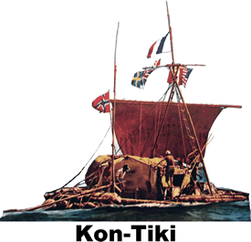In 1947, adventurer Thor Heyerdahl constructed a raft using ancient technology. Heyerdahl and a crew of six sailed 3770 miles on the Kon-Tiki, named for an Inca god. Their 97-day journey took them from Peru to the island of Puka Puka. Heyerdahl’s voyage proved that it was possible for ancient sailors to travel the Pacific Ocean, but not that it actually occurred.

Answer in complete sentences

*1. Explain why there are no written records from Beringia.

*2. Why did the sea level rise at the end of the ice age.

3. What did Thor Heyerdahl’s expedition prove?

The Maya

Deep in the jungle of Mesoamerica, a group of Maya city-states flourished for over a millennium. The Maya constructed great temples to bloodthirsty gods, then mysteriously went into a period of decline not once, but twice. Finally, by the time the Spanish arrived in 1517, little remained of the Maya beyond the legends and the clues they left behind for explorers to discover.
Archaeologists found evidence of Maya farming by about 400bce in the lowlands of what today is the southernmost part of Mexico, El Salvador, Belize, and eastern Honduras. The Maya cultivated squash, beans, potatoes, tomatoes, and cocoa, but corn was their primary food source and the reason the Maya population grew. Modern science indicates that over 70% ancient Maya diet came from corn.
The Maya believed that the gods created humans from dough made of corn and blood. To repay the gods, the Maya offered animal and human sacrifices. Maya inscriptions describe gruesome rituals that included priests removing the hearts of victims to satisfy the gods. Maya priests also cut themselves and sacrificed their own blood to worship their gods.
The most honored god in the Maya pantheon was Chaac, who provided rain to the Maya farmers. There are few rivers in the region, so the Maya were dependent upon Chaac’s kindness. Later Maya built huge cisterns to collect and store rainwater to provide citizens through months of drought.
Maya astronomers studied the heavens and kept careful records for their religious observances because the Maya believed sacrifices to the gods had to be carefully timed. The Maya used two calendars. An everyday calendar with 13 months of 20 days each was probably related to the appearance of the planet Venus. The Greeks and the Romans associated the planet Venus with the goddess of beauty, but the Maya seem to have associated Venus with war. The Maya also had a solar calendar that was similar to our own. Dates were so important that many Maya named their children after the name of the date of the birth.
The Maya created their calendar using a sophisticated mathematical system. While our mathematics is based on the number ten – or ‘base ten’ -- the Maya had a base twenty system. They represented one to four with dots. Five was a bar. Six to nine was a bar with dots above. Ten was two vertical bars. They drew a shell to represent zero. The system could be repeated to twenty.
Numbers bigger than twenty were depicted as stacks of multiples of twenty raised to various powers. The system was flexible and allowed Maya mathematicians to calculate sums that went up to the hundreds of millions.
The Maya were not a unified empire, but a collection of city-states ruled by kings. The king and the priests who advised him taxed the farmers and craftsmen of their state, oversaw justice, administered nearby villages, and waged war.
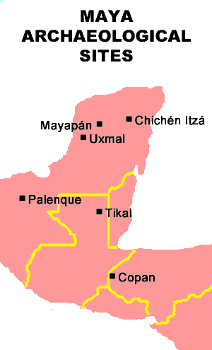Maya civilization thrived in the southern lowland Yucatan Peninsula from 250 to 900ce, then suddenly collapsed. There was a dramatic drop in population. Maya cities such as Copán and Tikal were abandoned and all new construction apparently stopped. We don’t know what happened, but theories include overpopulation, over-cultivation, drought, erosion, deforestation, warfare among cities, and internal rebellions. The collapse was probably a result of many of or all all of those factors to varying degrees. Historians refer to the period from 250 to 900 as the Classic Period of Maya history.
After the fall of the Classic Period, about seven new Maya cities including Uxmal and Chichén Itzá formed in the northern Yucatan Peninsula. These post-classical Maya constructed large canoes that allowed them to dominate trade throughout Mesoamerica.
Then about 1200, the post-classical Maya cities began to collapse as mysteriously as their earlier counterparts. The last significant Maya city remained at Mayapán. In 1441, Mayapán was sacked, burned, and abandoned after a revolt by its neighbors. One of the groups leading the revolt was the Mexica, a new group that was consolidating power in the central valley of Mexico. History knows the Mexica as the Aztecs—the next great power in the region.

Answer in Complete Sentences

- Why was Chaac such an important god to the Maya?  *2. In the space on the right, use Mayan numbers to write the date of your birth. If you were born on January 16, write 16. If you were born after the twentieth, remember to stack these numbers. Do your best, and don’t be concerned with your answer being incorrect.  *3. What are some reasons why the Maya city-states collapsed about 900? |  |  | Complete problem two in this space

*4. Use facts from the article to explain either why the Maya never formed an empire or why the civilization never had a single emperor. (You may answer either question)

Rediscovering the Maya

John Lloyd Stevens was an American lawyer and diplomat, but his passion was travel and exploration. While in London in 1836, Stevens met an artist named Frederick Catherwood, who shared his dream of exploring the uncharted land of Mesoamerica. Three years later, American President Martin Van Buren commissioned Stevens to be his ambassador to the region.
While in Mesoamerica, the two men made amazing discoveries. Stevens’ writing and Catherwood’s drawings also introduced many people of the nineteenth century to the ancient civilization for the first time.
The men learned of a wall of stone partially buried in the shrubs and trees of the jungle in the Yucatan Peninsula. They had encountered the remains of a temple in Copan, a city abandoned one thousand years earlier by the Maya. Hoping to dismantle the site and sell it to American museums, Stevens is said to have purchased all of Copan for fifty dollars.
In the middle of the nineteenth century, most people were aware of the great civilization created further to the north by the Aztecs in central Mexico, and the civilization of the Incas, high in the Andes Mountains of South America. The Maya, however, were all but unknown beyond their native land. There were some fantastic legends known to the modern inhabitants, but no other indications that the poor people who lived in the jungles of Central America were part of one of the most advanced ancient civilizations in history. Stevens and Catherwood eventually discovered thirty-six Maya cities including now famous sites at Palenque and Chichén Itzá.
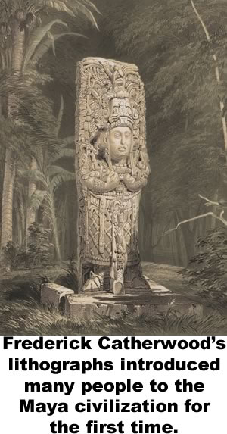Stevens and Catherwood also encountered many samples of the mysterious writing of the Maya carved in stone. We know now that the Maya were the only Mesoamericans to create a fully complex form of written language. Some Maya glyphs represented objects, like a pictographic language. Others represented sounds. In some cases, a single glyph represented both a sound and an object. Today we can identify more than 2000 Maya glyphs, but Stevens and Catherwood were unable to decipher the stones they discovered.
Maya codices were folding books on cloth made from tree bark. All but a handful were destroyed in 1562 by the order of a Spanish bishop.
Diego deLanda was sent to Mesoamerica to convert the Maya people to Christianity. When deLanda realized the Maya people were continuing to practice their traditional beliefs, he ordered all Maya texts to be burned. As he later wrote,

“We found a large number of books in these characters and, as they contained nothing in which were not to be seen as superstition and lies of the devil, we burned them all, which they (the Maya) regretted to an amazing degree, and which caused them much affliction.”

Before he did this, however, deLanda recorded his observations of Maya culture and examples of their writing. deLanda’s observations were lost for nearly three hundred years until they were rediscovered in 1862. The bishop’s manuscript was the first key to unlocking the puzzle of the previously unreadable Maya writing.
At least four of the original Maya books, called codices escaped the fire. As scholars learned to decipher the language, the books provided insight to Maya mathematics and astronomy. The codices tell us very little of everyday life for the Maya, and nothing about how the common people of the region lived. There are still many mysteries to discover as archaeologists continue to probe the jungle and find more clues about the Maya people. Researchers speculate that we will know a lot more about the Maya in the years to come.

Teotihuacan

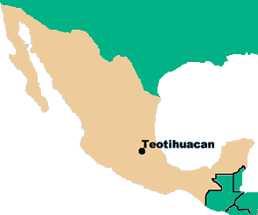A mysterious city developed in the Central Valley of Mexico about 100bce. It flourished for centuries until it was inexplicably destroyed about 650ce. The city featured two massive pyramids, a magnificent boulevard lined with temples and mansions, and the first apartment buildings in the Americas. Their people also practiced human sacrifice, and their brutal military conquered cultures throughout Mesoamerica.
The truth is that we don’t know what these people called themselves. We call the city Teotihuacan (pronounced tay-oh-tee-wah-KAHN), a term the Aztecs would use when they occupied the site centuries later.
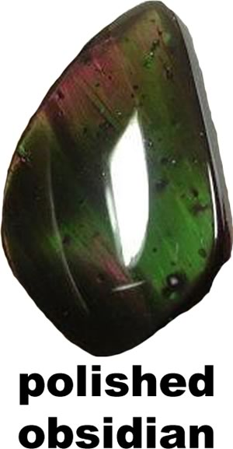People first settled along the banks of Lake Texcoco in the Valley of Mexico about 300BCE. They farmed the land and mined a stone called obsidian, which they made into jewelry, knives, and other tools. By about 100ce, Teotihuacan developed into a commercial city, home to sculptors, painters and potters.
Two enormous structures, later called the Pyramid of the Sun and the Pyramid of the Moon, dominated Teotihuacan along the Avenue of the Dead. These names reflect the religious beliefs of the Aztecs. We don’t know what the people who built them called the pyramids or the road.
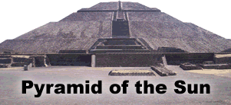Reaching a height of over two hundred feet, the Pyramid of the Sun is the third largest pyramid in the world. It was constructed about 100CE and expanded about 150 years later. Beneath the base of the pyramid, excavators found a 400-pound statue of Huehueteotl (pronounced we-we-TE-OH-tel), a fire god associated with wisdom. The pyramid was originally constructed over a deep cave. Scholars think the cave may be somehow connected to the ancient civilization’s belief in the underworld, where they believed their gods and ancestors lived.
The Pyramid of the Moon is the burial place of one of the city’s rulers. Smaller than its sister pyramid, it was also the burial place of people and animals that were sacrificed. Most of the walls of the pyramids are only recreations. In the 1880s, excavators used dynamite to explore the pyramids, causing tremendous damage.
The Avenue of the Dead was the city’s main thoroughfare. Smaller temples and homes for the ruling elite of the city lined the boulevard. A grid system of streets radiated from the avenue, creating the first urban infrastructure in the New World and access to housing for Teotihuacan’s workers.
About 250, the city stopped building pyramids and turned its attention to constructing apartment complexes. Excavators have found over 2000 apartment compounds, each housing between fifty and one hundred people. Most apartments were comfortable homes for tradespeople.
The city slowly began to decline in influence in the mid-400s. About 650, it was mysteriously abandoned and burned. Perhaps Teotihuacan was invaded, or its citizens may have faced a natural disaster such as an earthquake or a drought. Centuries later, the Aztecs settled along the lake and were so impressed by its pyramids that they named it Teotihuacan, or “city of the gods.”

Answer in complete sentences

1. Why did the people of Teotihuacan first settle in the Central Valley of Mexico?

2. Copy the sentence in the text tells us the people of Teotihuacan practiced human sacrifice.

3. What might have caused Teotihuacan to decline and fall?

The Aztecs
The Aztecs

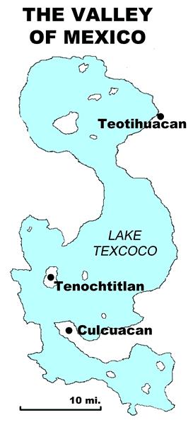When the Spanish conquistadors arrived in Mesoamerica, they learned of the rich and mighty Aztecs, the most powerful civilization in the New World. The Aztec capital was Tenochtitlan (pronounced te-noch-tit-lan), a city of more than 200,000 people filled with gold and silver. At the center of Tenochtitlan stood a towering pyramid topped by temples for the Aztec gods of sun and rain. Palaces for wealthy Aztec nobles surrounded the pyramid. Their great wealth and power obscured the fact that the Aztec hid even from themselves: not long before, they were a desperately poor nomadic people who wandered into the land that would become their home in the Valley of Mexico.
The Aztecs trace their history to Aztlán (pronounced ahz-LAHN), an area north of the Valley of Mexico, perhaps in what is now the southwestern United States. The Aztecs called themselves the Mexica (pronounced ma-SHEE-ka), a name from which Mexico is derived. The term Aztec means “person of Aztlán.” It was first used in the nineteenth century to distinguish the modern people of Mexico from the ancient civilization.
When the Aztecs arrived in the Valley of Mexico about 1300, their neighbors scorned them. The people of the valley considered themselves to be the proud descendants of the Toltec people, while they viewed the Aztecs as savage, uncivilized drifters.
The Aztecs wandered around the valley until the King of Culhuacan (pronounced kool-wha-kan) allowed the Aztecs a permanent home in exchange for working as mercenaries. Mercenaries are soldiers hired who fight for a living. The Aztecs also worked at lowly jobs that other people rejected. As time passed, the Culhuacan people began to respect the hard work brutal fighting skills of the Aztecs.
In 1323, the King offered his daughter in marriage to the Aztecs, thereby inviting them into his royal family. The Aztecs sacrificed the Culhuacan princess to Huitzilopochtli (pronounced wete-see-o-POK-ta-lee), their bloodthirsty god of war. The enraged king expelled the Aztecs, forcing them once again to wander the Valley of Mexico.
The Aztecs lived in a land of earthquakes that caused great destruction. Their legends said the gods destroyed and recreated the world over and over. They believed that the world would be destroyed once again if they did not satisfy their gods by providing them with human sacrifices.
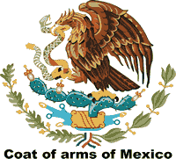 An Aztec priest had a vision that they should build their new home at a place where they found an eagle sitting on a cactus with a snake in its mouth. After two years of wandering, the Aztecs found that vision on a small island in the middle of Lake Texcoco, so they waded into the shallow lake to build new their home. The image of the eagle, cactus, and snake are part of the flag of present-day Mexico.
The Aztecs created farmland in their new home by constructing a series of artificial islands called chinampas. They marked off small areas with poles and clay walls, then filled the space with muck taken from other parts of the lake, leaving enough room for canoes to travel between the islands. The surfaces of the chinampas were fertile land that provided the Aztecs with as many as seven harvests a year.
In 1427, the Aztecs formed a secret agreement with two other kingdoms. This Triple Alliance conquered the other cultures of the valley and forced them to pay tribute, or payment for protection.
When they gained control of the Valley of Mexico, the Aztecs rewrote history to hide their humble origins. Tlacaelel (pronounced tlak-ah-lel) was the half-brother and closest advisor of Aztec King Moctezuma I. Tlacaelel ordered all old history books burned so there would be no memory of who the Aztecs once were. Tlacaelel’s new history said Huitzilopochtli chose the Aztecs to rule the valley. By erasing history, the Aztecs made their transformation complete. They had gone from peasants to princes.

Answer in Complete Sentences
*1. What did the Aztecs call themselves? Why do we refer to them as Aztecs?

2. What were chinampas?

3. What was the Triple Alliance?

The

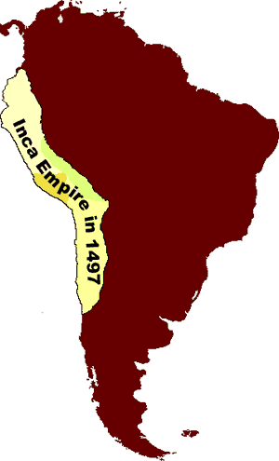The Incas
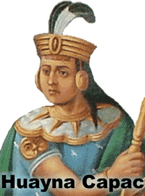It is 1493, and you struggle to breathe the thin mountain air of the Andes Mountains more than 10,000 feet above sea level. From afar, you witness a grand spectacle: the arrival of Huayna Capac, the ruler of the Four Regions.
Huayna Capac is carried in a great chair because he never walks in public. The ground is too dirty to accept his saliva, so the ruler spits into the hand of an attendant. The attendant then wipes his hand with a special cloth. The cloth and anything Huayna Capac has touched was sacred. It would eventually be burned in a great ceremony so that it did not fall into the hands of common people.
Huayna Capac was the Supa Inca, or “sole ruler” of Tawantinsuyu, a local word that means “four regions.” We know Tawantinsuyu by the title of their powerful rulers: the Incas. The Incas formed one of the world’s greatest empires in the forbidding climate of the Andes, the tallest mountains of the Western Hemisphere.
The people believed the Sapa Inca was a living god, whose ancestor was Inti, the sun god. The Incas believed Inti was their protector because his light provided life for the crops and the people. Even the Sapa Inca was careful to respect the sun god.
Quilla was the moon and Inti’s wife. The Incas would watch throughout the month as Quilla would grow from a small sliver in the sky to a beautiful sphere that lit the night sky, only to recede and return the next month. The children of Inti and Quilla were the stars.
Despite the severity of the high altitude climate, the Incas were at least the third empire to develop in the Andes. The Chavìn controlled the coastal regions of what is now Ecuador, Peru, and Bolivia as early as 900bce. They were followed by the Wari (500 – 1100) and the Tiwanaku (tee-wan-AH-ku) (300 – 1000ce) in the south. The Incas did not gain prominence until after the fall of the Wari and the Tiwanaku.
Pachacuti (pah-chah-COO-tee)— Huayna Capac’s grandfather—ruled from 1438 to 1471. Pachacuti transformed the kingdom of Cusco in modern Peru to a mighty empire through negotiation and warfare. He sent representatives to local rulers inviting them to join his empire. If the local ruler refused, Pachacuti sent his brutal army to force them to give up.
Pachacuti was probably the emperor who ordered the construction of the mysterious Machu Picchu. Located 7000 miles above sea level near Cusco, Machu Micchu probably served as a country estate for Pachacuti. The site includes more than 200 buildings and three large temples. Because the city was inaccessible for thousands of years to outsiders, it is the best remaining example of an Inca city.
For hundreds of years, explorers had heard tales of city so high it was always hidden by clouds. In 1911, Yale professor Hiram Bingham found Machu Picchu and later wrote about it in National Geographic. Bingham has often been compared with Indiana Jones in “Raiders of the Lost Ark.” The “Lost City of the Incas” is now easily reached by railroad. Every year, thousands of tourists flock to what has become the most familiar icon of Inca civilization.
In 1532, Francisco Pizarro conquered the Incas and claimed their land for Spain. By that time, the glory of the Inca empire had faded. Huayna Capac and his eldest son died only a few days apart in 1527, possibly from smallpox. The European disease seems to have reached the Andes ever before the arrival of the first Spanish conquistadors.
The Inca Empire fell into the hands of Huayna Capac’s younger sons, who fought a civil war that weakened the empire. Wracked by disease and divided leadership, the Incas were no match for the guns and cannons of their invaders.

Answer in Complete Sentences
1. Explain why the people had such great respect for the Sapa Inca. Use specific statements from the text to support your answers.

2. Explain how Pachacuti used negotiation to build his empire.

*3. Why was Machu Picchu hidden from the outside world until 1911?

Life in the Inca World
Life in the Inca World

The Incas lived high in the Andes, a mountain range along the western edge of South America. They lived without horses, iron tools, the wheel, or writing. But in the space of less than 100 years, they built spectacular cities of stone and ruled over millions of people.
By 1491, the Inca controlled an area that stretched more than 2500 miles from north to south, but in some places no more than fifty miles from east to west. It included perhaps ten million people. At its height, the empire of the Incas rivaled the Mongols, the Romans, or Alexander the Great.
The Incas adapted to life in the Andes. The climate of their empire ranged from frigid cold to desert or tropical, often within a few miles due to the steep, rocky slopes of the Andes.
The empire included speakers of over 100 languages, but Inca rulers spoke Quechua, (KWEE-cha) still the speech of 8 to 10 million people in the mountains of Peru, Bolivia, and Ecuador.
Although the Incas did not know how to use iron, they crafted great cities using only stone tools. Inca engineers constructed walls with huge blocks that fit together without the use of mortar. Despite the volatility of their earthquake-prone empire, many Inca building remain standing today.
Many of the empires most impressive buildings were in Cusco, the Inca’s capital city. Four wide gateways in the city led to an enormous raised plaza at its center. The center was carpeted in white sand carried up the Andes from the Pacific Ocean and raked daily by workers. The walls surrounding the plaza were cut from enormous blocks of stone cut so finely that one explorer said, “the point of a pin could not have been inserted in one of the joints.” Cusco means “navel,” for the Incas believed their capital was the center of the world and the sacred home of their gods.
The Inca’s greatest engineering achievement was a network of more than 14,000 miles of roads and bridges. Relay runners called chasquis (CHAH-skis) were trained to carry messages from the emperor to their furthest reaches of his realm.
Chasquis needed to have strong minds and strong legs. The Incas did not have writing, so each runner would have to memorize his message and immediately run to the next station.
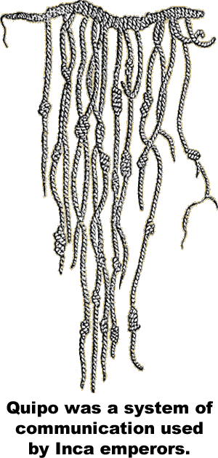Some Chasquis carried quipo, (KWEE-po) legnths of different colored knotted strongs tield to a central cord. Inca rulers used the “talking knots” to keep records of who paid taxes, how often roads were maintained, and where troops were stationed. The chasquis delivered the messages, but only specially trained scholars understood the messages hidden in the colors and weaving of this mysterious system.
Though the roads were well maintained, the chasqui has to run up and down the steps of mountains. The Incas had no use for the wheel because they lacked strong animals capable of pulling a cart or plow.
The largest animals the Inca knew were llamas —distant relatives of the camel. Although llamas are capable of carrying only a small amount of weight on their backs, they are nimble enough to navigate the steps of the Inca road system.
The Incas crossed canyons and rivers with swinging bridges constructed of rope. Inca engineers developed a canal system and built huge cisterns to hold water for the dry seasons.
Inca farmers cut strips of level land called terraces into the mountains. The terraces provided the Incas with flat surfaces to grow peppers, squash, peanuts and maize. The forbidding climate forced the Incas to rely heavily on root vegetables such as the potato and manioc. Manioc is also known as tapioca.
The lack of large animals limited meat in the Inca diet, but they hunted deer, llamas, ducks and guinea pigs. The Inca road system made it possible to transport fish from the Pacific Ocean to villages high in the Andes.

Spanish conquistadors vanquished the Incas in 1533. In the years that followed, Spain imposed laws forbidding local customs. They required the Incas to adopt Spanish customs and clothing. Resistance from the Andes continued for centuries. Today, Spanish is the primary language of western South America, but in 1993, the Constitution of Peru declared Quechua—the language of the Incas—to also be official.

Answer in complete sentences
*1. What is the significance of Cusco’s name?

*2. Explain why the Spanish conquistadors could not easily pull carts along the Inca road system.

3. How did the Incas manage to create land level enough for farming on mountainsides?

The Fall of the Incas
The Fall of the Incas

In 1532, the Inca Empire fell to a Spanish force of only 168 men and 62 horses. Francisco Pizarro his conquistadors crushed one of the world’s mightiest empires without a single Spanish casualty. Pizarro had cannons, gunpowder and armor, but the Incas vastly outnumbered his small army. Pizarro’s good fortune was to arrive in the Andes at the exact moment when the Incas were wracked by a great sickness and divided leadership.
Huayna Capac was the last of three great Inca rulers. In 1520, he marched an army north to capture land that is now part of Ecuador. The Inca ruler sent his son, Atahualpa (at-a-WHAL-pa) to lead an expedition into enemy territory, but the younger man was ambushed and forced to retreat.
Huayna Capac took command of his army to avenge the humiliation of his son. After many long and bloody battles, Huayna Capac subdues his foes. Enjoying the climate of his newly conquered territory, the Inca ruler ordered that a new palace be constructed for himself and his son.
The Sapa Inca (“Sole Ruler”) ruled his empire from his northern palace for five years, until a great sickness passed through empire. Modern evidence suggests that the sickness was smallpox, a European disease carried south by traders long before the first European arrived in Inca territory. Smallpox spread throughout the trade routes of the empire and may have taken the lives of more than 200,000 people.
Atahualpa had not distinguished himself, so when Huayna Capac became ill, he passed over Atahualpa and named another son to replace him. Before the ruler died, though, the illness also killed his heir.
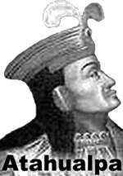When the Inca nobles in Cusco, the Inca capital, learned of Huayna Capac’s death, they named another son, Washkar, to be Supa Inca. Atahualpa, who had been living with his father in the northern capital, declared himself to be ruler. Both brothers had powerful armies. Washkar commanded the royal army in Cusco, while Atahualpa commanded the northern army used to expand the empire. The two sons of Huayna Capac plunged the empire into a brutal civil war.
Atahualpa and Washkar called on the mummified bodies of past Supa Incas to assist them. The Incas believed their rulers were living descendants of Inti, the sun god. When the Sapa Inca died, his body was preserved and treated as if it were still living. Mummies were carried into battle to advise the generals.
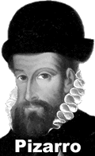The civil war seemed to end in 1532 when Atahualpa’s army captured Washkar. Washkar watched as his wives, children, and relatives were executed in front of his eyes. Then, as Atahualpa made his triumphant return to Cusco as Sapa Inca, word spread of the arrival of bearded pale men riding atop huge animals.
The Inca not know of writing, horses, or metal weapons, so what happened next took the empire by surprise. A priest appeared before Atahualpa and the Incas as Pizarro kept his horses and cannon hidden from view. The priest presented Atahualpa with a holy book, telling the ruler that it was the word of God. The Sapa Inca did not understand writing, so he tossed the book on the ground. When the book dropped, Pizarro waved a white scarf to signal the attack to begin.
Spanish soldiers on horseback began to charge as others pulled the cannon from hiding and fired into the crowd. The terrified Incas trampled one another as they attempted to flee. Pizarro grabbed Atahualpa and dragged the Sapa Inca through the crowd as a hostage.
Learning the Spanish valued silver and gold, Atahualpa promised to fill a room bigger than his prison with gold and silver in exchange for his freedom. The Inca ruler sent word to his generals first to kill Washkar, then to strip Cusco of gold and silver metals and turn it over to his captors as ransom. The Sapa Inca had not lived in the city for many years, so he had little attachment to Cusco or the people who lived there. For the next six months, precious metals were carted away from Cusco to Pizarro’s small camp. The Spaniards melted the gold and silver down to bricks and shipped the precious metals to Spain.
c

