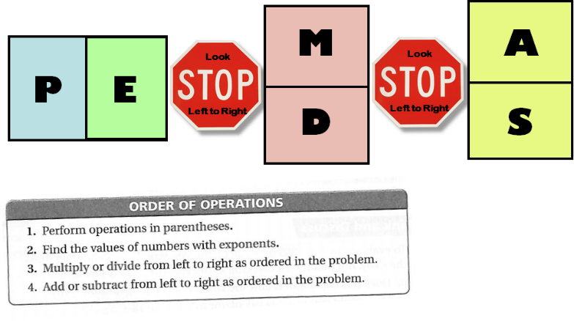
1. A caterer charges a setup fee of $50, plus $20 per person. How much will the caterer charge if 35 people attend the party?

2. At a community center there are a total of 11 tables in the dining room. Six of the tables seat 4 people each. Five of the tables seat 8 people each. What is the maximum number of people who can sit at the tables in the dining room?

3. The ticket prices to a play are $5.00 for teachers and $3.00 for students. How much will it cost for a group of 71 students and 5 teachers to see the play?

4. Ms. Meléndez needs to replace the batteries in 20 calculators. Each calculator uses 4 batteries. The batteries are sold in packages of 16. How many packages of batteries does Ms. Meléndez need to buy?

5. The library at your school just received a new shipment of books. In order to make room for the new books the old books are being put into 2 types of boxes for storage. A small box can hold 5 books and a big box can hold 10 books. If we have 8 small boxes and 6 big boxes, how many books can we put in storage?

1. A caterer charges a setup fee of $50, plus $20 per person. How much will the caterer charge if 35 people attend the party?

2. At a community center there are a total of 11 tables in the dining room. Six of the tables seat 4 people each. Five of the tables seat 8 people each. What is the maximum number of people who can sit at the tables in the dining room?

3. The ticket prices to a play are $5.00 for teachers and $3.00 for students. How much will it cost for a group of 71 students and 5 teachers to see the play?

4. Ms. Meléndez needs to replace the batteries in 20 calculators. Each calculator uses 4 batteries. The batteries are sold in packages of 16. How many packages of batteries does Ms. Meléndez need to buy?

5. The library at your school just received a new shipment of books. In order to make room for the new books the old books are being put into 2 types of boxes for storage. A small box can hold 5 books and a big box can hold 10 books. If we have 8 small boxes and 6 big boxes, how many books can we put in storage?

