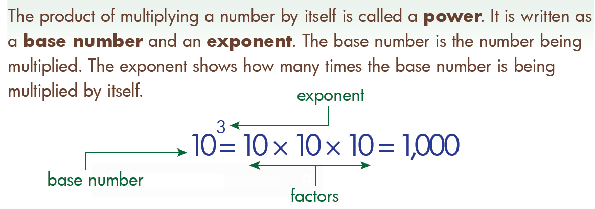
Exponent Homework 1 Name: ________________________________
1) 7⁰ = ______ 2) 8¹ = ______
_____3) How could 125 be written
in exponential Form?
- 5²
- 25 x 5
- 5³
- 5 x 5 x 5 _____5) What number below could be the result of
squaring a base number?
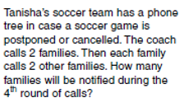
4) Complete the chart
6)

- 12 b. 16
- 55 d. 20

Exponential Form | Expanded Form | Standard Form
3²
4³
2⁴

Exponent Homework 1 Name: ________________________________
1) 7⁰ = ______ 2) 8¹ = ______
_____3) How could 125 be written
in exponential Form?
- 5²
- 25 x 5
- 5³
- 5 x 5 x 5 _____5) What number below could be the result of
squaring a base number?
4) Complete the chart
6)

- 12 b. 16
- 55 d. 20

Exponential Form | Expanded Form | Standard Form
3²
4³
2⁴

