Name: __________________________

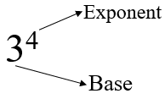
Exponents

The exponent tells us how many times to multiply the base by itself.
3⁴ means: 3 x 3 x 3 x 3 = 81 (3⁴ ≠ 3 x 4)
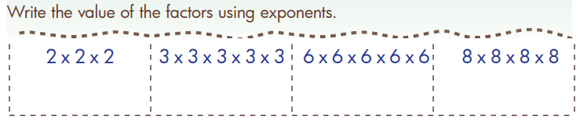
How is 5 x 5 x 5 x 5 x 5 + 6 x 6
written in exponential notation?
- 5⁴ + 6
- 5² + 6²
- 5⁵ + 6²
- 5⁵ + 6

2³
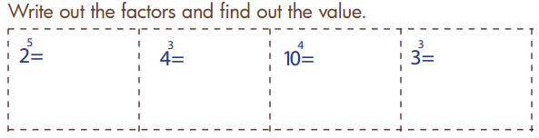

Name: __________________________

Exponents

The exponent tells us how many times to multiply the base by itself.
3⁴ means: 3 x 3 x 3 x 3 = 81 (3⁴ ≠ 3 x 4)
How is 5 x 5 x 5 x 5 x 5 + 6 x 6
written in exponential notation?
- 5⁴ + 6
- 5² + 6²
- 5⁵ + 6²
- 5⁵ + 6

How is 5 x 5 x 5 x 5 x 5 + 6 x 6
written in exponential notation?
- 5⁴ + 6
- 5² + 6²
- 5⁵ + 6²
- 5⁵ + 6

2³

