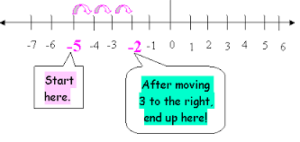
Homework
Find the difference between integers

Answer the questions below.

1. The temperature changed from -1 degrees to +10 degrees. How much did the temperature change by?
2. The temperature changed from 0 degrees to +10 degrees. How much did the temperature change by?
3. The temperature changed from -6 degrees to +10 degrees. How much did the temperature change by?
4. The temperature changed from -4 degrees to +5 degrees. How much did the temperature change by?
5. The temperature changed from -4 degrees to +1 degree. How much did the temperature change by?
6. The temperature changed from -6 degrees to 0 degrees. How much did the temperature change by?
7. The temperature changed from -8 degrees to 0 degrees. How much did the temperature change by?
8. The temperature changed from -6 degrees to -2 degrees. How much did the temperature change by?

