Name: _____________________________
Fraction Homework #2 Multiplying and Dividing Fractions with Mixed Review Word Problems
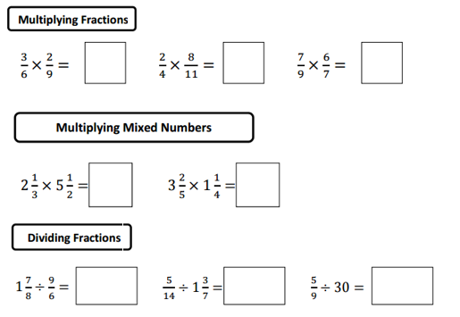

Mixed Review for Fraction Operations using Problem Solving
- After a party, 5/8 of the cake is left over. That night, big brother eats 1/3 of the cake that was left. How much is left over after that?

- You have 7 5/8 feet of yarn to make a bracelet. You only use 4 1/8 yards for the bracelet. How much yarn is left over?

- Jamar is trying to fit his encyclopedia on a shelf. Each book in his encyclopedia is 2¼ inches thick. The self is 2¼ feet wide. How many books will Jamar be able to fit?

- The Hubba Bubba Bubble Gum Tape is 6 feet long. How many 2¼ inch pieces can the tape be cut into?

- Chris has a 3 ½ feet long board of wood. He needs to cut out 4 pieces that are each 2/3 foot long. Find the combined length of the 4 pieces. Does he have enough wood?

